Oracle 19c RAC 搭建

操作系统检查与配置 4

1、OS空间和配置检查 4

2、swap空间检查 4

3、调整shm文件大小，该文件大小与物理内存大小一致 4

4.创建libcap连接 4

网络检查及配置 5

1.关闭NetworkManager服务 5

2.关闭防火墙 5

3.关闭SELinux 5

4.禁用Transparent HugePages（THP） 5

5. 配置NOZEROCONF 6

6.配置hosts文件 6

7.配置网络 6

创建用户、用户组和目录并授权 8

设置oracle用户和grid用户的环境变量 8

rpm包安装 9

系统参数配置 10

1、内核参数设置 10

2、配置oracle、grid用户的shell限制 10

3、配置login 11

4、关闭其他服务 11

5、配置NTP服务 11

配置裸盘 14

1、虚拟机添加2条属性参数 14

2. 生成规则文件 14

3. 生成规则 14

4. 将结果复制到 99-oracle-asmdevices.rules 14

5. 启动udev 15

安装grid 15

1、上传grid安装包至$ORACLE_HOME目录下并解压 15

2、运行安装程序进行安装 15

3、完成安装后进行资源检查 27

4、创建数据盘和快速恢复盘 29

安装oracle软件 31

1、上传数据库安装包至$ORACLE_HOME路径下并解压 31

2、运行安装程序进行安装 31

使用DBCA创建数据库 38

安装后的检查 46

检查集群实例运行状态 46

检查CRS状态 46

查看集群中节点配置信息 46

查看集群间的表决磁盘信息 46

查看集群scan vip信息 47

查看集群scan listener信息 47

手动漂移scan ip 47

手工漂移vip 47

设置sqlprompt 48

搭建ADG 48

写在前面 48

1、主库设置force logging模式 48

2、修改主库为归档模式 48

3、主库添加standby redo log 49

4、配置主/备库为静态监听（两个节点都要配置） 50

5、配置主/备库tnsnames.ora（两个节点都要配置） 51

6、备库创建相应目录 52

7、创建备库口令文件 52

8、修改主库参数并生成pfile文件 53

9、备库启动至nomount状态 54

10、开始duplicate 54

11、备库创建spfile 55

12、备库复制密码口令文件到ASM 55

13、备库添加rac资源 55

14、启动MRP进程 55

15、主备配置dg_borker 55

16、主备进行切换 58

17、维护 63

## 操作系统检查与配置

### 1、OS空间和配置检查

检查命令

# grep MemTotal /proc/meminfo

建议配置：最少8GB，推荐16GB以上

### 2、swap空间检查

# grep SwapTotal /proc/meminfo

Swap建议至少配置32GB

增加swap方法：

通过此种方式进行swap 的扩展，首先要计算出block的数目。具体为根据需要扩展的swapfile的大小，以M为单位。block=swap分区大小*1024, 例如，需要扩展64M的swapfile，则：block=64*1024=65536.

然后做如下步骤：

#dd if=/dev/zero of=/swapfile bs=1024 count=65536

#mkswap /swapfile

#swapon /swapfile

#vi /etc/fstab

增加/swapfile swap swap defaults 0 0

# cat /proc/swaps 或者# free –m //查看swap分区大小

# swapoff /swapf //关闭扩展的swap分区

### 3、调整shm文件大小，该文件大小与物理内存大小一致

修改fstab，使用size指定大小

# vim /etc/fstab

tmpfs /dev/shm tmpfs defaults, size=16384M 0 0 #使用size进行大小指定

重新进行挂载

# mount -o remount /dev/shm

### 4.创建libcap连接

[root@rac1 /]# cd lib64/  
[root@rac1 lib64]# ls -lrt libcap*

[root@rac1 lib64]# ls -lrt libcap.so.2

[root@rac1 lib64]# ln -s libcap.so.2.22 libcap.so.2.16

## 网络检查及配置

### 1.关闭NetworkManager服务

两个节点都使用root关闭NetworkManager开机启动并重启网络

自启动设置：

systemctl stop NetworkManager

systemctl disable NetworkManager 设置开机不启动

systemctl enable network 设置开机启动

启/停服务：

service NetworkManager stop 或 systemctl start NetworkManager

service network start 或 systemctl start network

### 2.关闭防火墙

systemctl stop firewalld

systemctl disable firewalld

### 3.关闭SELinux

vi /etc/sysconfig/selinux

SELINUX=disabled

### 4.禁用Transparent HugePages（THP）

首先检查THP的启用状态：

cat /sys/kernel/mm/transparent_hugepage/defrag

[always] madvise never

如果输出结果为[always]表示透明大页启用了。[never]表示透明大页禁用、[madvise]表示（只在MADV_HUGEPAGE标志的VMA中使用THP

这个状态就说明都是启用的。

编辑rc.local文件： vim /etc/rc.d/rc.local

增加下列内容：

if test -f /sys/kernel/mm/transparent_hugepage/enabled; then

echo never > /sys/kernel/mm/transparent_hugepage/enabled

fi

if test -f /sys/kernel/mm/transparent_hugepage/defrag; then

echo never > /sys/kernel/mm/transparent_hugepage/defrag

fi

保存退出，然后赋予rc.local文件执行权限：

chmod +x /etc/rc.d/rc.local

最后重启系统，以后再检查THP应该就是被禁用了

cat /sys/kernel/mm/transparent_hugepage/enabled

### 5. 配置NOZEROCONF

在/etc/sysconfig/network增加以下内容

NOZEROCONF=yes

### 6.配置hosts文件

vi /etc/hosts增加如下内容

#public ip

10.8.7.112 rac1.qdxw.com rac1

10.8.7.113 rac2.qdxw.com rac2

#Private IP

10.0.0.1 rac1-priv

10.0.0.2 rac2-priv

#Virtual IP

10.8.7.114 rac1-vip.qdxw.com rac1-vip

10.8.7.115 rac2-vip.qdxw.com rac2-vip

### 7.配置网络

节点1：

[root@rac1 network-scripts]# pwd

/etc/sysconfig/network-scripts

[root@rac1 network-scripts]# cat ifcfg-ens161

TYPE=Ethernet

PROXY_METHOD=none

BROWSER_ONLY=no

BOOTPROTO=static

DEFROUTE=yes

IPV4_FAILURE_FATAL=no

NAME=ens161

DEVICE=ens161

ONBOOT=yes

HOTPLUG=no

IPADDR=10.8.7.112

NETMASK=255.255.255.0

GATEWAY=10.8.7.254

DNS1=10.8.7.111

[root@rac1 network-scripts]# cat ifcfg-ens224

TYPE=Ethernet

PROXY_METHOD=none

BROWSER_ONLY=no

BOOTPROTO=static

DEFROUTE=yes

IPV4_FAILURE_FATAL=no

IPV6INIT=yes

DEVICE=ens224

ONBOOT=yes

HOTPLUG=no

IPADDR=10.0.0.1

NETMASK=255.255.0.0

节点2：

root@rac2 network-scripts]# pwd

/etc/sysconfig/network-scripts

[root@rac2 network-scripts]# cat ifcfg-ens161

TYPE=Ethernet

PROXY_METHOD=none

BROWSER_ONLY=no

BOOTPROTO=static

DEFROUTE=yes

IPV4_FAILURE_FATAL=no

NAME=ens161

DEVICE=ens161

ONBOOT=yes

HOTPLUG=no

IPADDR=10.8.7.113

NETMASK=255.255.255.0

GATEWAY=10.8.7.254

DNS1=10.8.7.111

[root@rac2 network-scripts]# cat ifcfg-ens224

TYPE=Ethernet

PROXY_METHOD=none

BROWSER_ONLY=no

BOOTPROTO=static

DEFROUTE=yes

IPV4_FAILURE_FATAL=no

NAME=ens224

DEVICE=ens224

ONBOOT=yes

HOTPLUG=no

IPADDR=10.0.0.2

NETMASK=255.255.0.0

# systemctl restart network /重启网卡

## 创建用户、用户组和目录并授权

groupadd -g 1000 oinstall

groupadd -g 1020 asmadmin

groupadd -g 1021 asmdba

groupadd -g 1022 asmoper

groupadd -g 1031 dba

groupadd -g 1032 oper

useradd -u 1100 -g oinstall -G asmadmin,asmdba,asmoper,oper,dba grid

useradd -u 1101 -g oinstall -G dba,asmdba,asmadmin,oper oracle

mkdir -p /u01/app/19.0.0/grid

mkdir -p /u01/app/grid

mkdir -p /u01/app/oracle/product/19.0.0/db_1

chown -R grid:oinstall /u01

chown -R oracle:oinstall /u01/app/oracle

chmod -R 775 /u01/

## 设置oracle用户和grid用户的环境变量

grid用户：

[root@rac1 ~]# su - grid

[grid@rac1 ~]$ vi .bash_profile

export TMP=/tmp

export TMPDIR=$TMP

export ORACLE_SID=+ASM1 # RAC1节点只填这个

export ORACLE_SID=+ASM2 # RAC2节点只填这个

export ORACLE_BASE=/u01/app/grid

export ORACLE_HOME=/u01/app/19.0.0/grid

export PATH=/usr/sbin:$PATH

export PATH=$ORACLE_HOME/bin:$PATH

export LD_LIBRARY_PATH=$ORACLE_HOME/lib:/lib:/usr/lib

export CLASSPATH=$ORACLE_HOME/JRE:$ORACLE_HOME/jlib:$ORACLE_HOME/rdbms/jlib

umask 022

oracle用户：

export TMP=/tmp

export TMPDIR=$TMP

export ORACLE_SID=orcl1 # RAC1只写这一个

export ORACLE_SID=orcl2 # RAC2只写这一个

export ORACLE_UNQNAME=orcl

export ORACLE_BASE=/u01/app/oracle

export ORACLE_HOME=$ORACLE_BASE/product/19.0.0/db_1

export TNS_ADMIN=$ORACLE_HOME/network/admin

export PATH=/usr/sbin:$PATH

export PATH=$ORACLE_HOME/bin:$PATH

export LD_LIBRARY_PATH=$ORACLE_HOME/lib:/lib:/usr/lib

$ source .bash_profile使配置文件生效

需要注意的是ORACLE_UNQNAME是数据库名，创建数据库时指定多个节点是会创建多个实例，ORACLE_SID指的是数据库实例名

## rpm包安装

配置本地yum源

[yumlist]

name=yumlist

baseurl=file:///yumlist

enabled=1

gpgcheck=0

gpgkey=file:///etc/pki/rpm-gpg/RPM-GPG-KEY-redhat-beta,file:///etc/pki/rpm-gpg/RPM-GPG-KEY-redhat-release

yum install -y compat*

yum install -y compat-libcap*

yum install -y gcc*

yum install -y gcc-c++*

yum install -y glibc-devel*

yum install -y ksh*

yum install -y libstdc++-devel*

yum install -y libaio-devel*

注：

1.还需要安装cvuqdisk，对于12cR2版本，该rpm包位于Grid_Home的cv/rpm/下

## 系统参数配置

### 1、内核参数设置

vi /etc/sysctl.conf

kernel.msgmnb = 65536

kernel.msgmax = 65536

fs.aio-max-nr = 1048576

fs.file-max = 6815744

kernel.shmmni = 4096

kernel.shmmax =物理内存*0.8*1024*1024*1024*1024

kernel.shmall = shmmax/shmmni

kernel.sem = 5010 641280 5010 128

net.ipv4.ip_local_port_range = 9000 65500

net.core.rmem_default = 262144

net.core.rmem_max = 4194304

net.core.wmem_default = 262144

net.core.wmem_max = 1048586

net.ipv4.tcp_wmem = 262144 262144 262144

net.ipv4.tcp_rmem = 4194304 4194304 4194304

Vm.nr_hugepages = 40968

注：Vm.nr_hugepages计算公式为HugePages_Total=ceil(SGA_MAX_SIZE/Hugepagesize)+N

确认修改内核

[root@rac1 ~]# sysctl –p

### 2、配置oracle、grid用户的shell限制

vi /etc/security/limits.conf

grid soft nproc 2047

grid hard nproc 16384

grid soft nofile 1024

grid hard nofile 65536

oracle soft nproc 2047

oracle hard nproc 16384

oracle soft nofile 1024

oracle hard nofile 65536

grid soft stack 10240

oracle soft stack 10240

oracle hard memlock 3145728

oracle soft memlock 3145728

grid hard memlock 3145728

grid soft memlock 3145728

注：memlock计算公式为Vm.nr_hugepages*2048

### 3、配置login

vi /etc/pam.d/login

session required pam_limits.so

### 4、关闭其他服务

systemctl stop avahi-dnsconfd

systemctl stop avahi-daemon

systemctl stop cups

systemctl stop postfix

systemctl stop smartd

systemctl disable avahi-dnsconfd

systemctl disable avahi-daemon

systemctl disable cups

systemctl disable postfix

systemctl disable smartd

### 5、配置NTP服务

确认ntp的安装

1）确认是否已安装ntp

【命令】rpm –qa | grep ntp

若只有ntpdate而未见ntp，则需删除原有ntpdate。如：

ntpdate-4.2.6p5-22.el7_0.x86_64

fontpackages-filesystem-1.44-8.el7.noarch

python-ntplib-0.3.2-1.el7.noarch

2）删除已安装ntp

【命令】yum –y remove ntpdate-4.2.6p5-22.el7.x86_64

3）重新安装ntp

【命令】yum –y install ntp

配置ntp服务

1）修改所有节点的/etc/ntp.conf

【命令】vi /etc/ntp.conf

【内容】

restrict 192.168.6.3 nomodify notrap nopeer noquery //当前节点IP地址

restrict 192.168.6.2 mask 255.255.255.0 nomodify notrap //集群所在网段的网关（Gateway），子网掩码（Genmask）

2）选择一个主节点，修改其/etc/ntp.conf

【命令】vi /etc/ntp.conf

【内容】在server部分添加一下部分，并注释掉server 0 ~ n

server 127.127.1.0

Fudge 127.127.1.0 stratum 10

3）主节点以外，继续修改/etc/ntp.conf

【命令】vi /etc/ntp.conf

【内容】在server部分添加如下语句，将server指向主节点。

server 192.168.6.3

Fudge 192.168.6.3 stratum 10

===修改前===

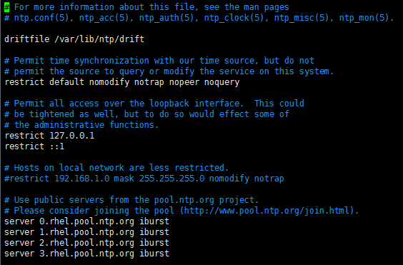

===修改后===

节点1（192.168.6.3）：

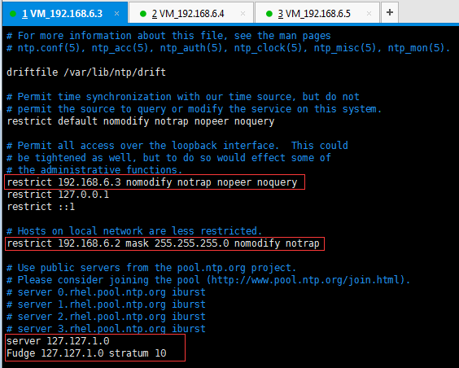

节点2

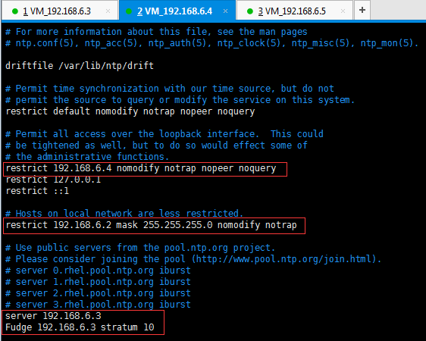

两个节点执行【命令】vi /etc/sysconfig/ntpd 增加-x

OPTIONS="-x -p /var/run/ntpd.pid -g"

设置NTP开机启动

NTP与chronyd冲突，检查chronyd是否自启

[root@hisdb-rac1 ~]# systemctl is-enabled chronyd.service

enabled

关闭chronyd自启

[root@hisdb-rac1 ~]# systemctl disable chronyd.service

## 配置裸盘

### 1、虚拟机添加2条属性参数

disk.EnableUUID = "TRUE"

disk.locking="FALSE"

### 2. 生成规则文件

touch /etc/udev/rules.d/99-oracle-asmdevices.rules

或者

touch /usr/lib/udev/rules.d/99-oracle-asmdevices.rules

### 3. 生成规则

没有对sdb进行分区,执行如下shell脚本，

for i in b c d e f ;

do

echo "KERNEL==\"sd*\", SUBSYSTEM==\"block\", PROGRAM==\"/usr/lib/udev/scsi_id --whitelisted --replace-whitespace --device=/dev/\$name\", RESULT==\"`/usr/lib/udev/scsi_id --whitelisted --replace-whitespace --device=/dev/sd$i`\", SYMLINK+=\"asm-disk$i\", OWNER=\"grid\", GROUP=\"asmadmin\", MODE=\"0660\""

done

### 4. 将结果复制到 99-oracle-asmdevices.rules

将第二步的输出粘贴入 99-oracle-asmdevices.rules 这个文件

KERNEL=="sd*", SUBSYSTEM=="block", PROGRAM=="/usr/lib/udev/scsi_id --whitelisted --replace-whitespace --device=/dev/$name", RESULT=="36000c2948ef9d9e4a7937bfc65888bc8", NAME="asm-diskb", OWNER="grid", GROUP="asmadmin", MODE="0660"

Load updated block device partition tables.

# /sbin/partprobe /dev/sdb

### 5. 启动udev

systemctl restart systemd-udev-trigger.service

systemctl enable systemd-udevd.service

## 安装grid

### 1、上传grid安装包至$ORACLE_HOME目录下并解压

[grid@rac1 ~]$ cd $GRID_HOME

[grid@rac1 grid]$ pwd

/u01/app/19.3.0/grid

[grid@rac1 grid]$ ll

total 2821472

-rw-r--r-- 1 grid oinstall 2889184573 Nov 15 11:20 LINUX.X64_193000_grid_home.zip

[grid@rac1 grid]$ unzip LINUX.X64_193000_grid_home.zip

### 2、运行安装程序进行安装

[grid@rac1 grid]$ ./gridSetup.sh

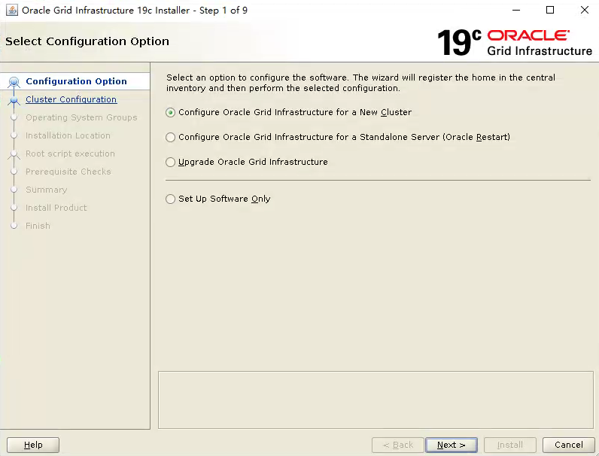

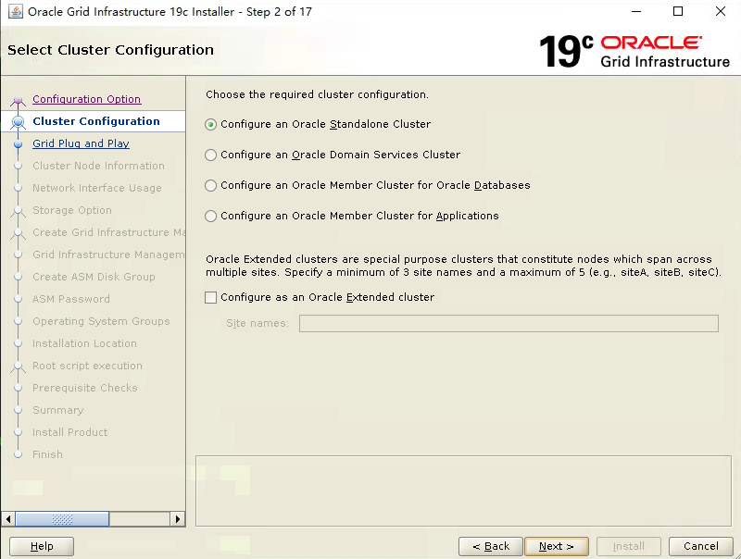

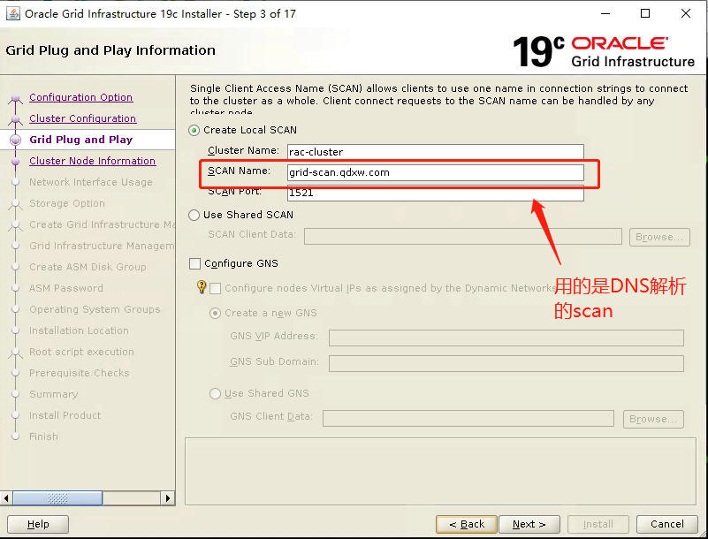

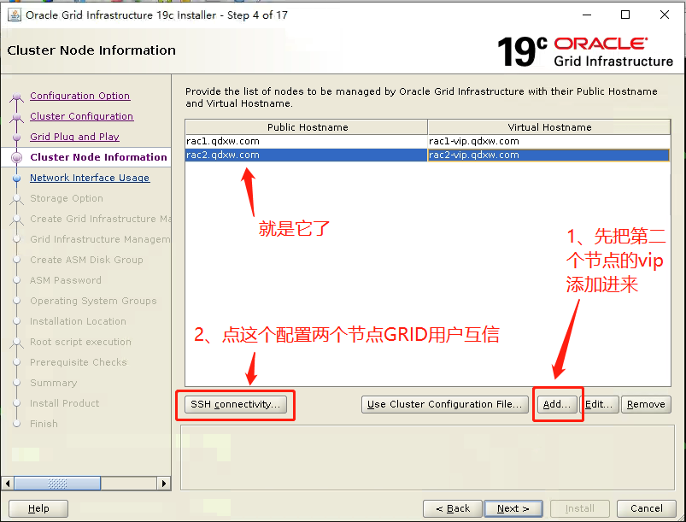

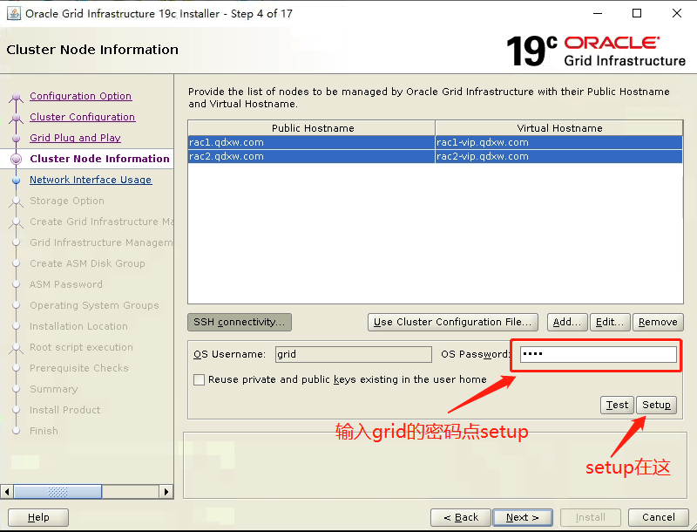

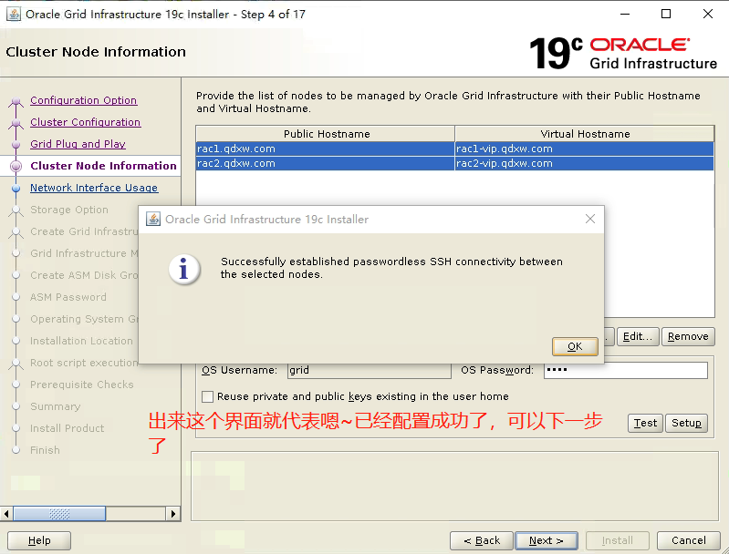

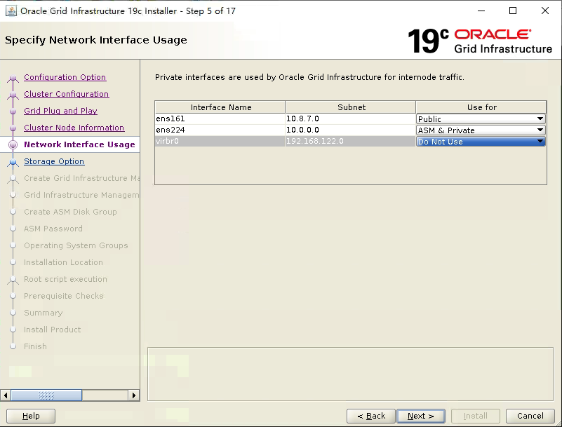

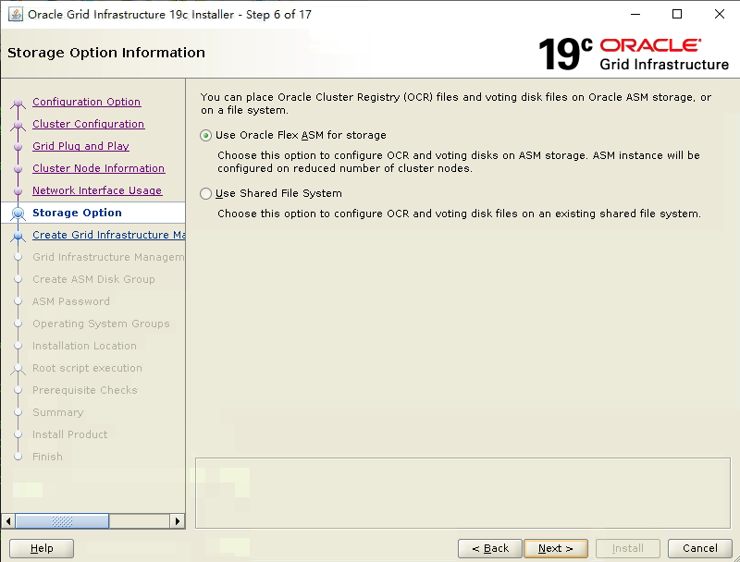

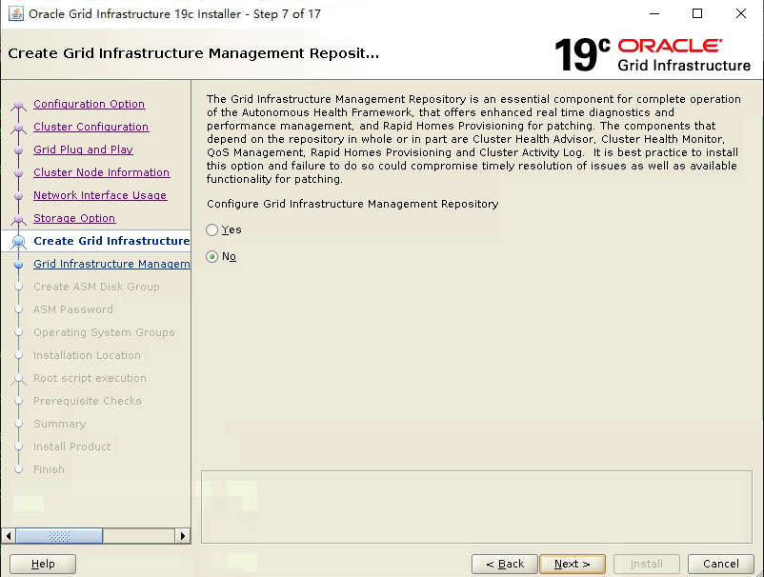

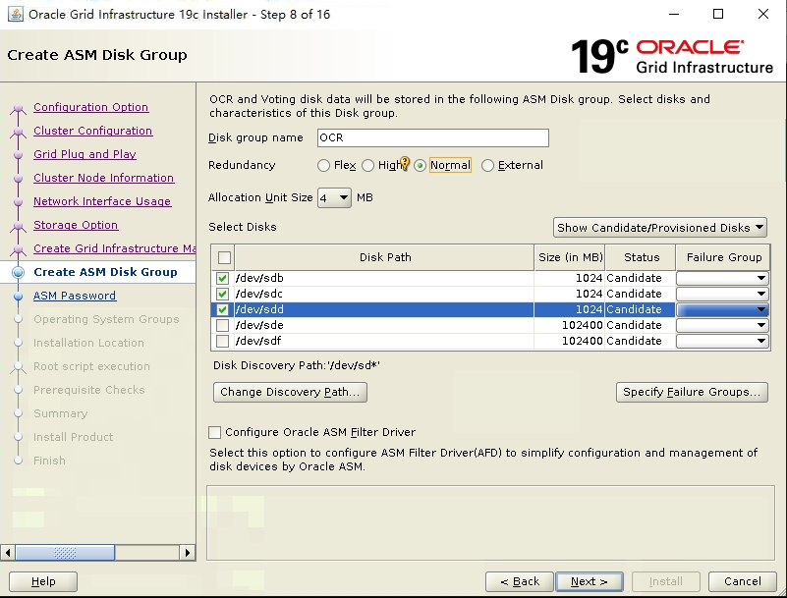

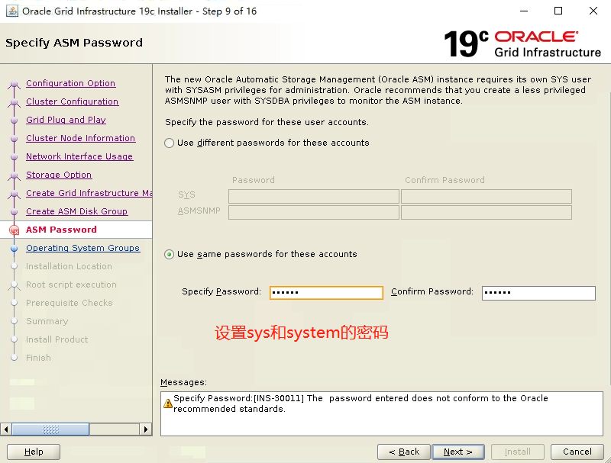

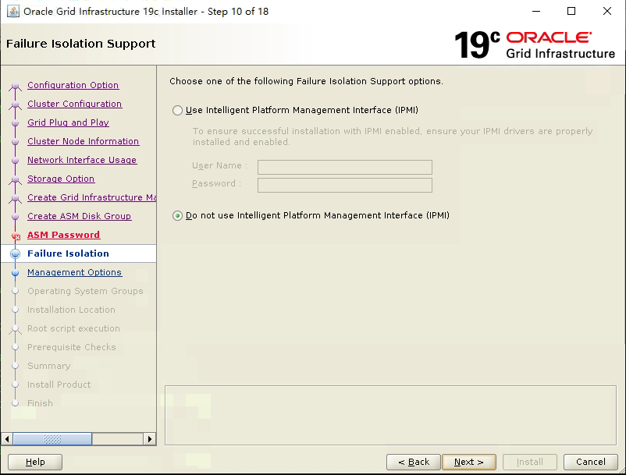

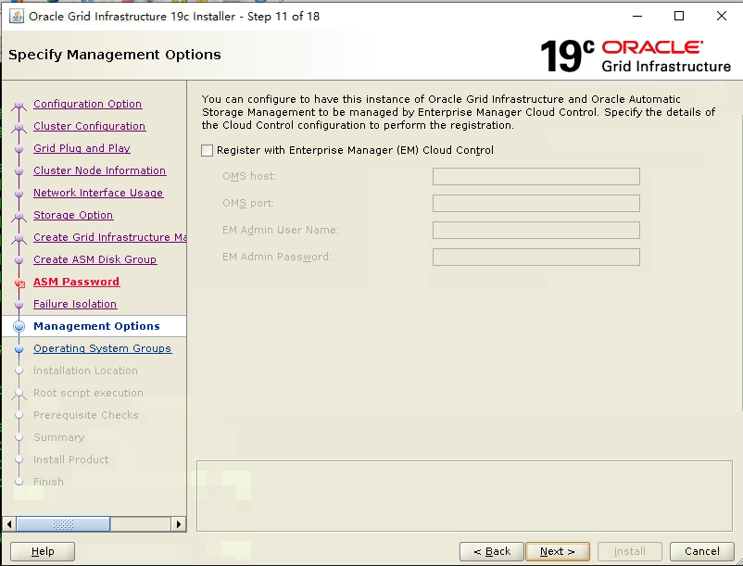

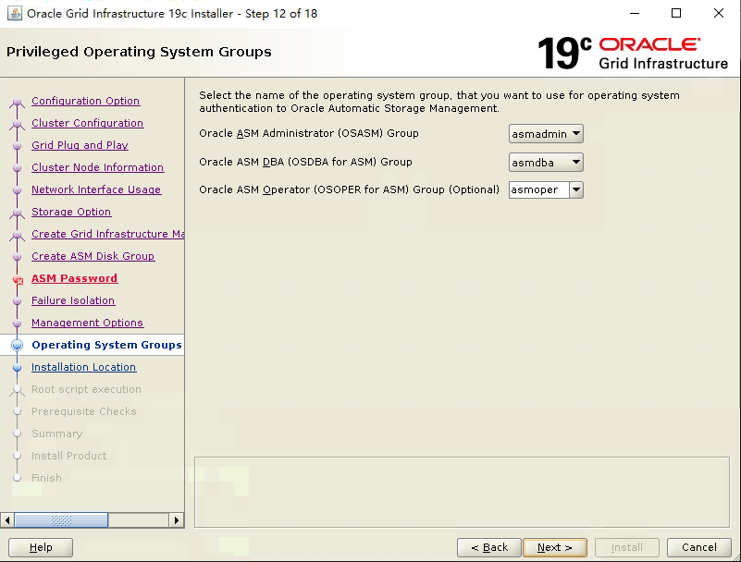

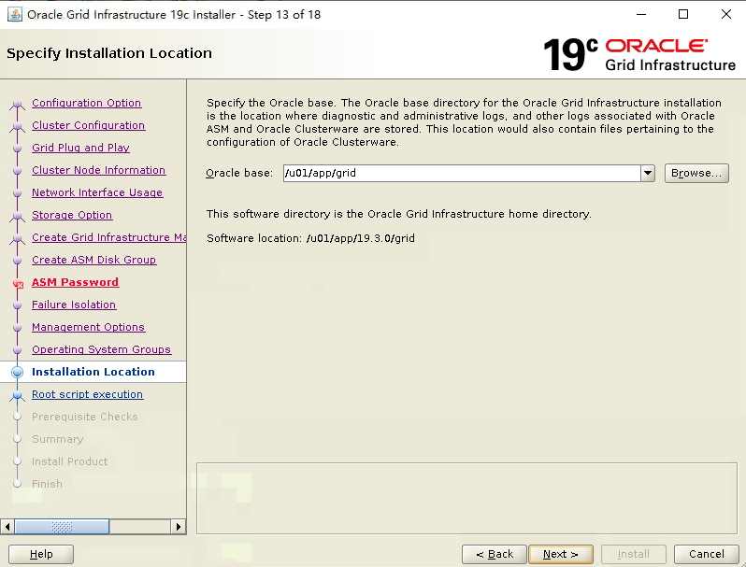

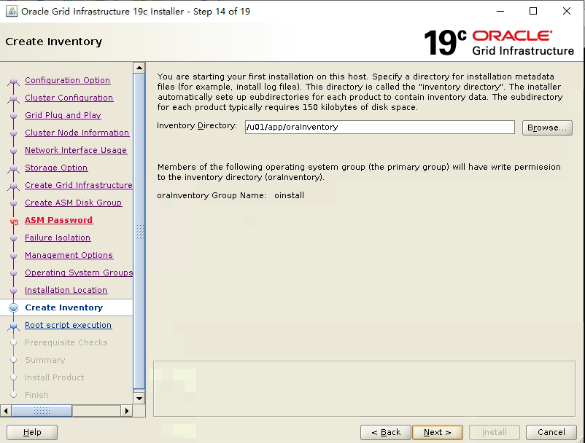

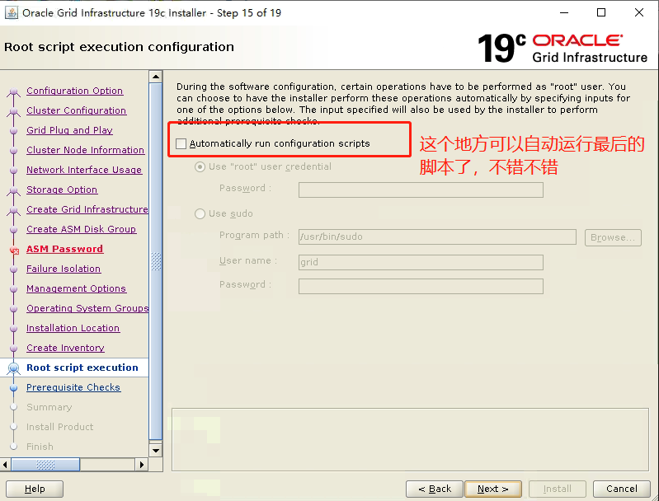

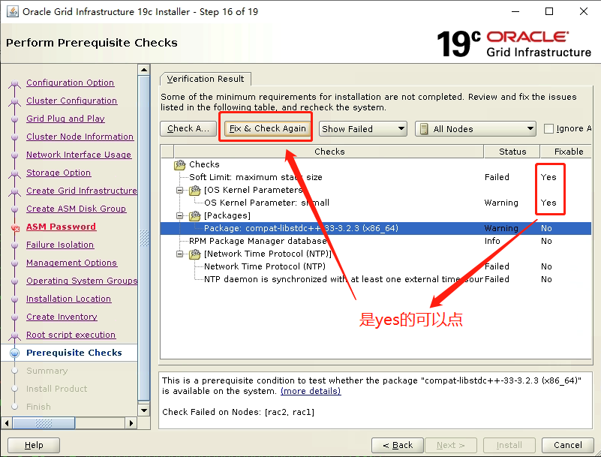

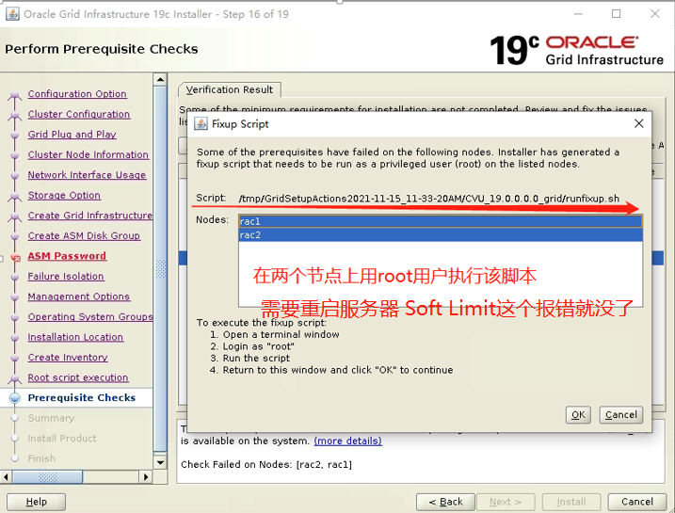

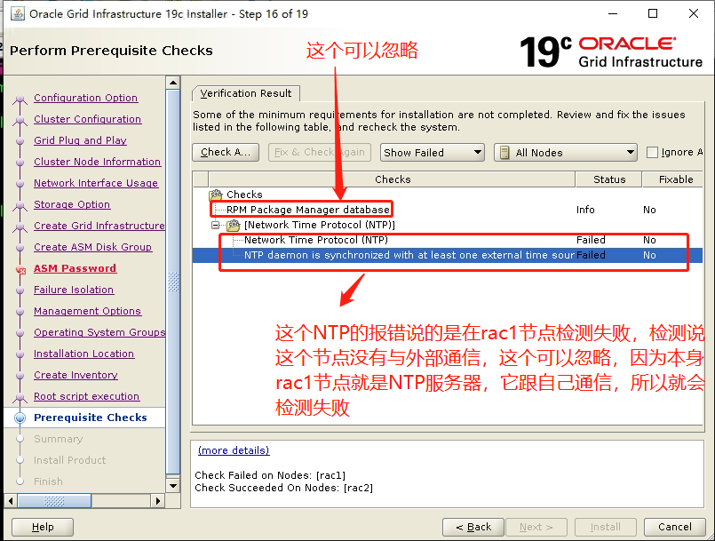

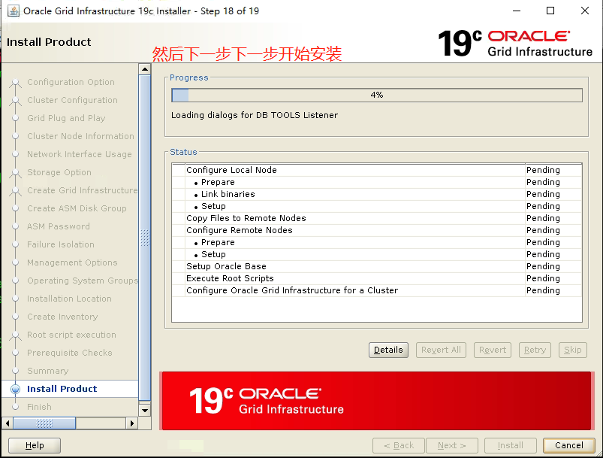

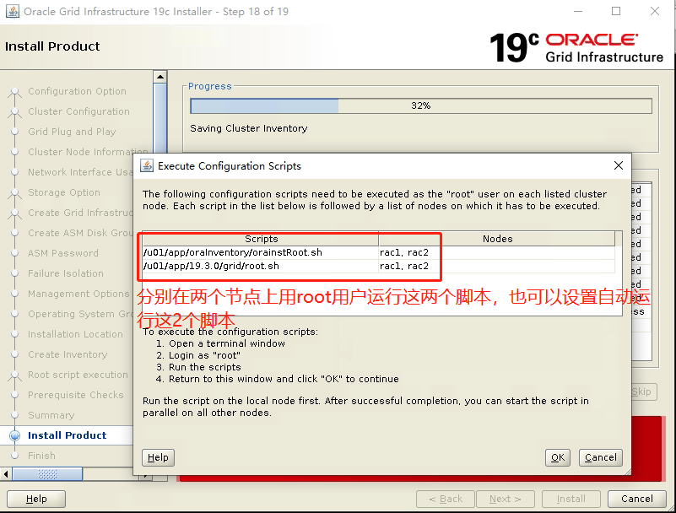

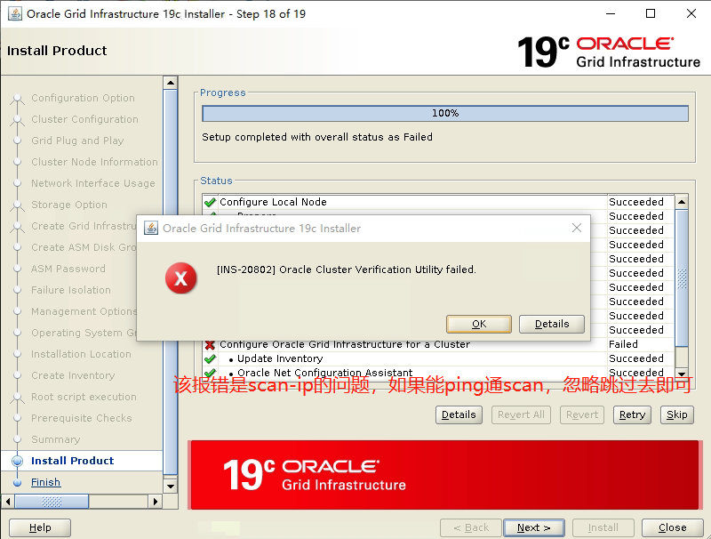

### 3、完成安装后进行资源检查

检查crs状态

[grid@rac1 ~]$ crsctl check crs

CRS-4638: Oracle High Availability Services is online

CRS-4537: Cluster Ready Services is online

CRS-4529: Cluster Synchronization Services is online

CRS-4533: Event Manager is online

检查Clusterware资源

[grid@rac1 ~]$ crsctl status res -t

--------------------------------------------------------------------------------

Name Target State Server State details

--------------------------------------------------------------------------------

Local Resources

--------------------------------------------------------------------------------

ora.LISTENER.lsnr

ONLINE ONLINE rac1 STABLE

ONLINE ONLINE rac2 STABLE

ora.chad

ONLINE ONLINE rac1 STABLE

ONLINE ONLINE rac2 STABLE

ora.net1.network

ONLINE ONLINE rac1 STABLE

ONLINE ONLINE rac2 STABLE

ora.ons

ONLINE ONLINE rac1 STABLE

ONLINE ONLINE rac2 STABLE

--------------------------------------------------------------------------------

Cluster Resources

--------------------------------------------------------------------------------

ora.ASMNET1LSNR_ASM.lsnr(ora.asmgroup)

1 ONLINE ONLINE rac1 STABLE

2 ONLINE ONLINE rac2 STABLE

3 OFFLINE OFFLINE STABLE

ora.LISTENER_SCAN1.lsnr

1 ONLINE ONLINE rac2 STABLE

ora.LISTENER_SCAN2.lsnr

1 ONLINE ONLINE rac1 STABLE

ora.LISTENER_SCAN3.lsnr

1 ONLINE ONLINE rac1 STABLE

ora.OCR.dg(ora.asmgroup)

1 ONLINE ONLINE rac1 STABLE

2 ONLINE ONLINE rac2 STABLE

3 OFFLINE OFFLINE STABLE

ora.asm(ora.asmgroup)

1 ONLINE ONLINE rac1 Started,STABLE

2 ONLINE ONLINE rac2 Started,STABLE

3 OFFLINE OFFLINE STABLE

ora.asmnet1.asmnetwork(ora.asmgroup)

1 ONLINE ONLINE rac1 STABLE

2 ONLINE ONLINE rac2 STABLE

3 OFFLINE OFFLINE STABLE

ora.cvu

1 ONLINE ONLINE rac1 STABLE

ora.qosmserver

1 ONLINE ONLINE rac1 STABLE

ora.rac1.vip

1 ONLINE ONLINE rac1 STABLE

ora.rac2.vip

1 ONLINE ONLINE rac2 STABLE

ora.scan1.vip

1 ONLINE ONLINE rac2 STABLE

ora.scan2.vip

1 ONLINE ONLINE rac1 STABLE

ora.scan3.vip

1 ONLINE ONLINE rac1 STABLE

检查集群节点

[grid@rac1 ~]$ olsnodes -n

rac1 1

rac2 2

检查两个节点上的Oracle TNS监听器进程

[grid@rac1 ~]$ ps -ef|grep lsnr|grep -v 'grep'|grep -v 'ocfs'|awk '{print$9}'

LISTENER_SCAN2

LISTENER_SCAN3

LISTENER

ASMNET1LSNR_ASM

确认针对Oracle Clusterware文件的Oracle ASM功能：

如果在 Oracle ASM 上安装过了OCR和表决磁盘文件，则以Grid Infrastructure 安装所有者的身份，使用给下面的命令语法来确认当前正在运行已安装的Oracle ASM:

[grid@rac1 ~]$ srvctl status asm -a

ASM is running on rac1,rac2

ASM is enabled.

ASM instance +ASM1 is running on node rac1

Number of connected clients: 1

Client names: rac1:_OCR:rac-cluster

ASM instance +ASM2 is running on node rac2

Number of connected clients: 1

Client names: rac2:_OCR:rac-cluster

### 4、创建数据盘和快速恢复盘

官方文档中规定了不同冗余策略下OCR、Voting disk、Database和Recovery所需的大小

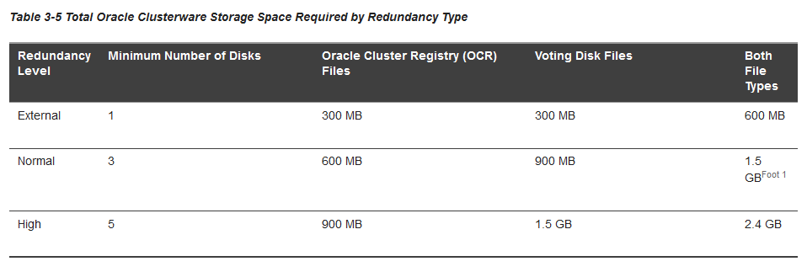

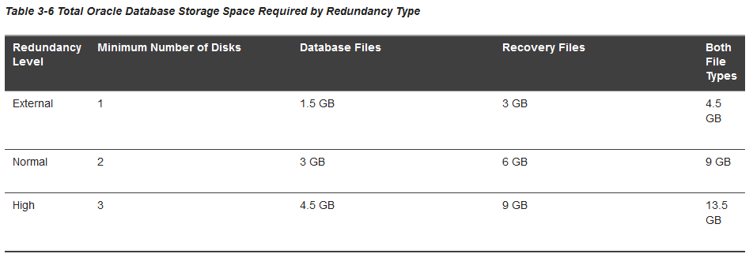

只在节点rac1执行即可

进入grid用户下

[grid@rac1 ~]$ asmca

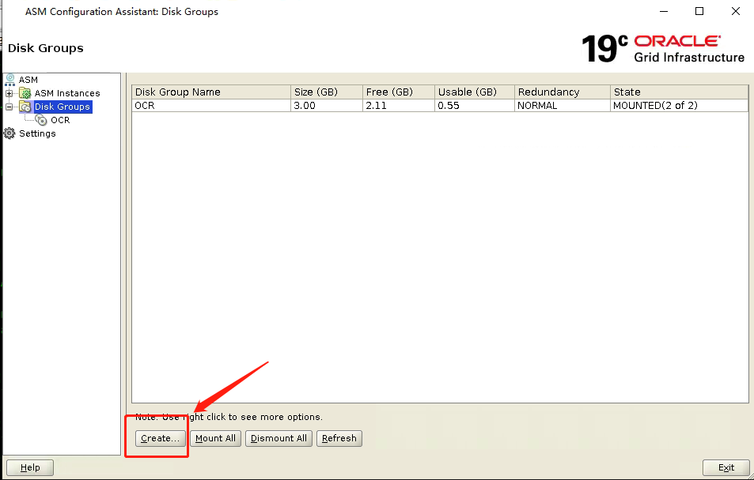

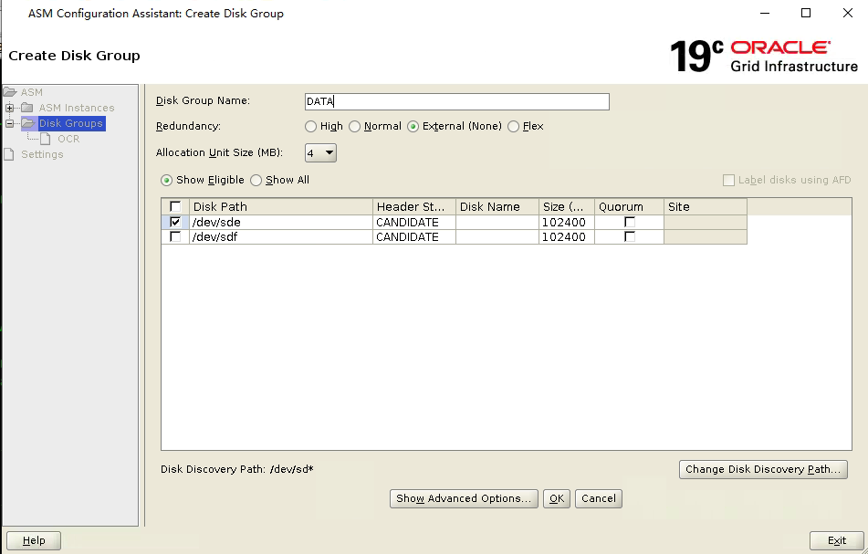

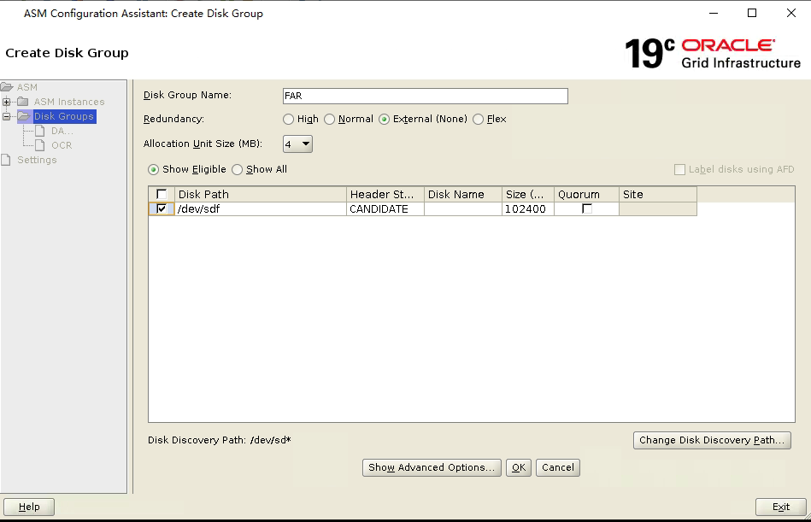

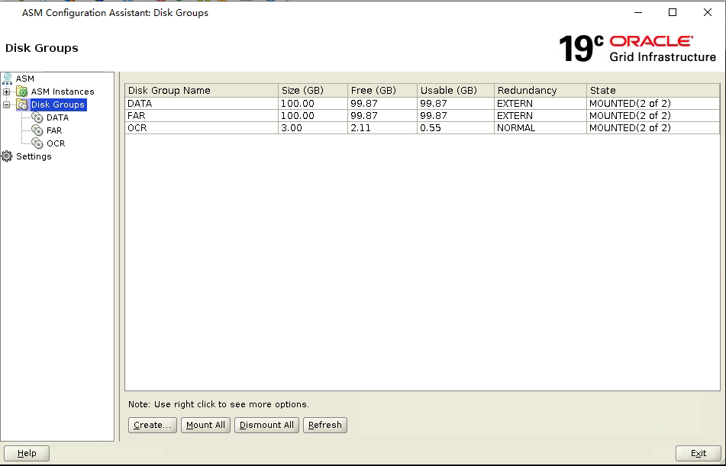

## 安装oracle软件

### 1、上传数据库安装包至$ORACLE_HOME路径下并解压

[oracle@rac1 ~]$ cd $ORACLE_HOME

[oracle@rac1 db_1]$ pwd

/u01/app/oracle/product/19.3.0/db_1

[oracle@rac1 db_1]$ ls

LINUX.X64_193000_db_home.zip

[oracle@rac1 db_1]$ unzip LINUX.X64_193000_db_home.zip

### 2、运行安装程序进行安装

[oracle@rac1 db_1]$ ./runInstaller

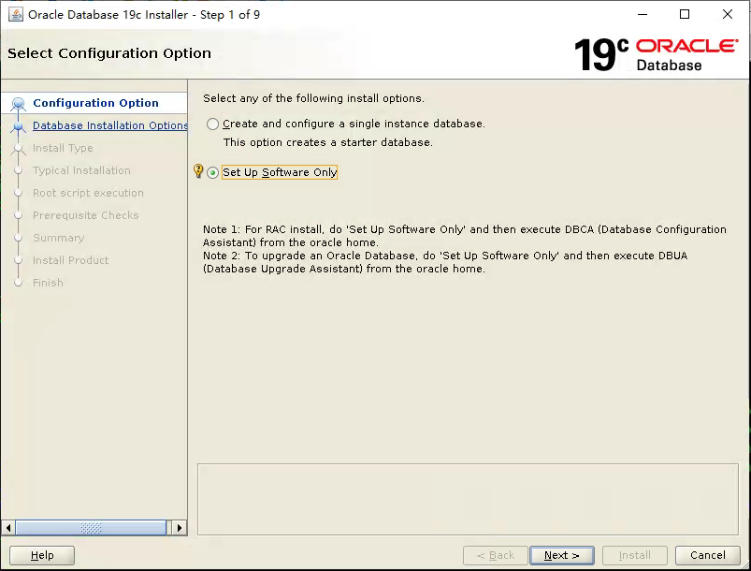

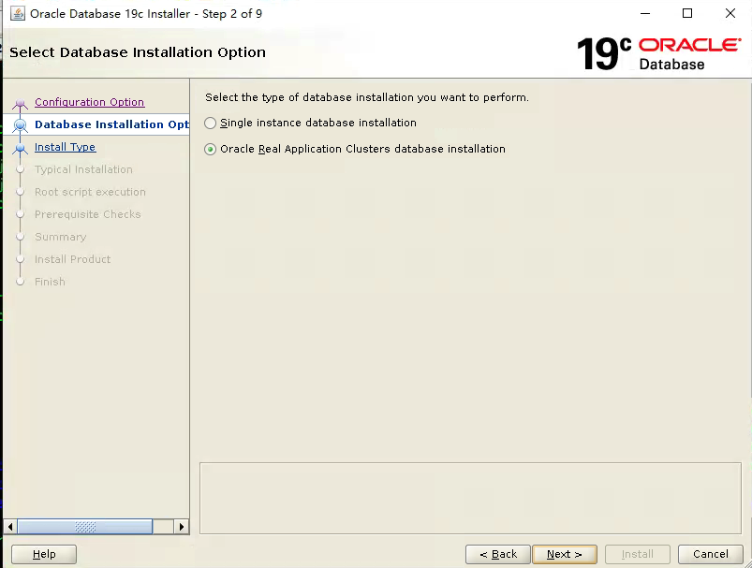

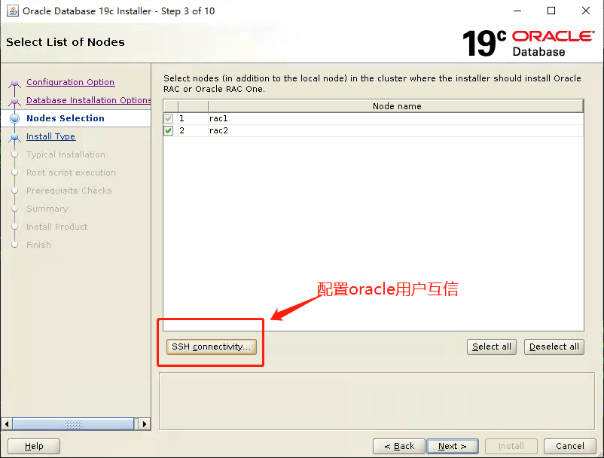

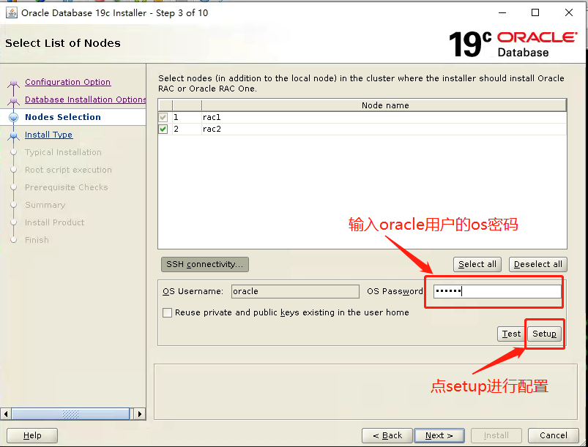

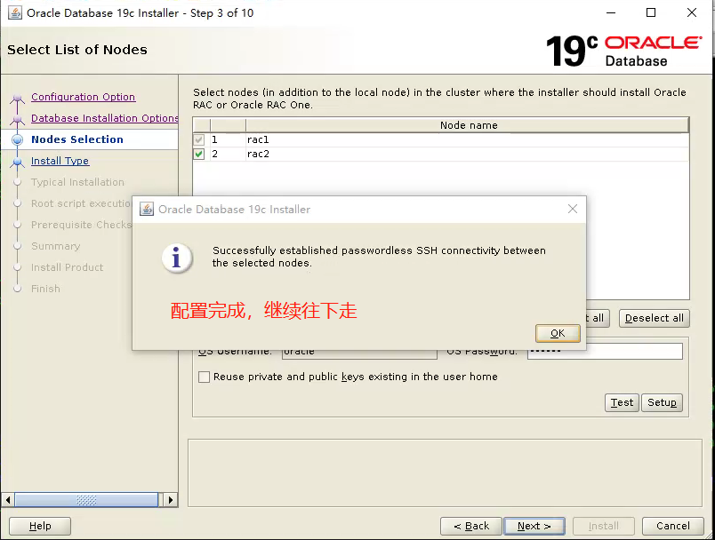

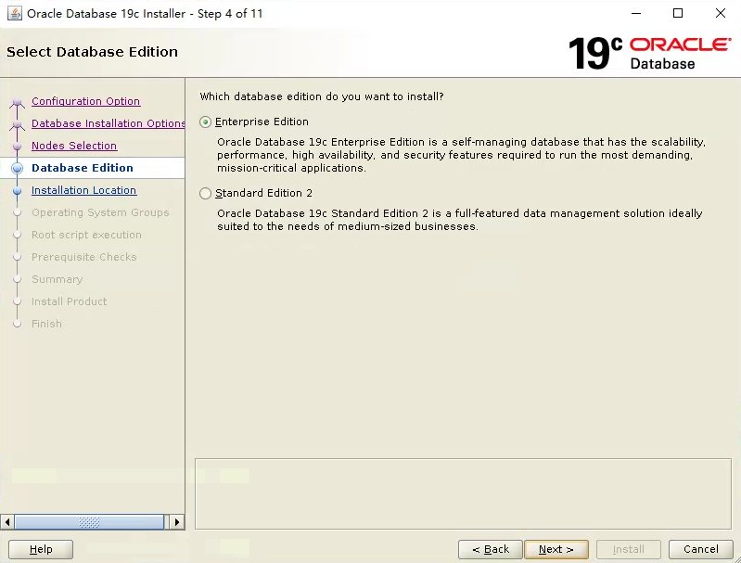

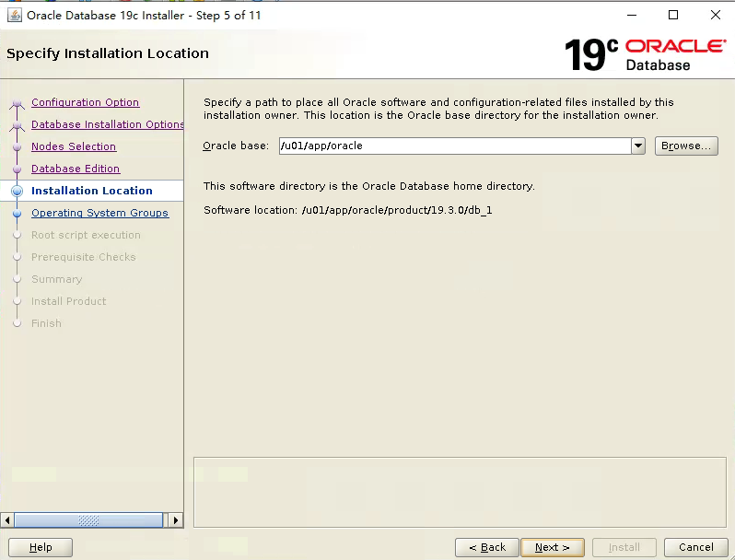

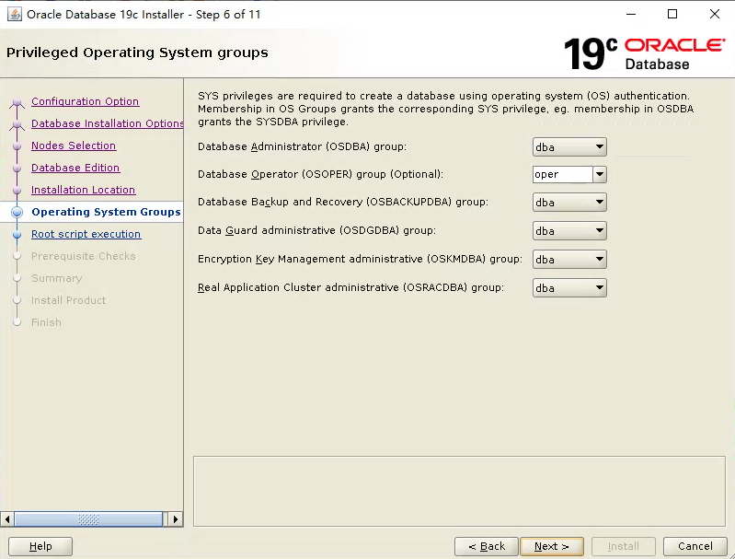

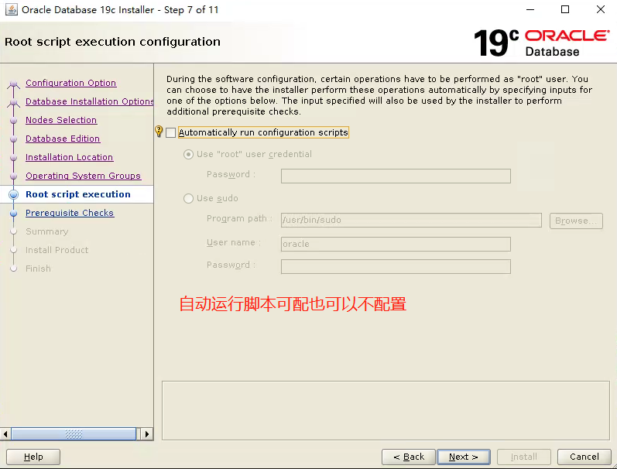

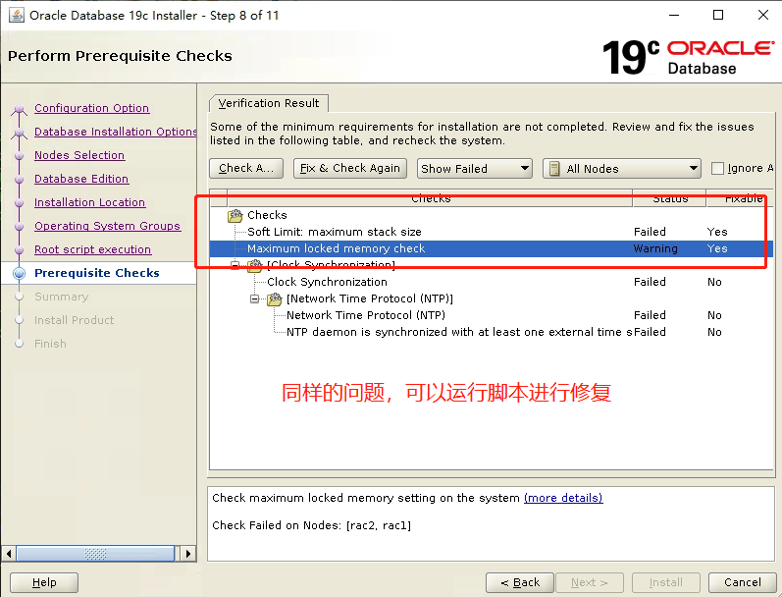

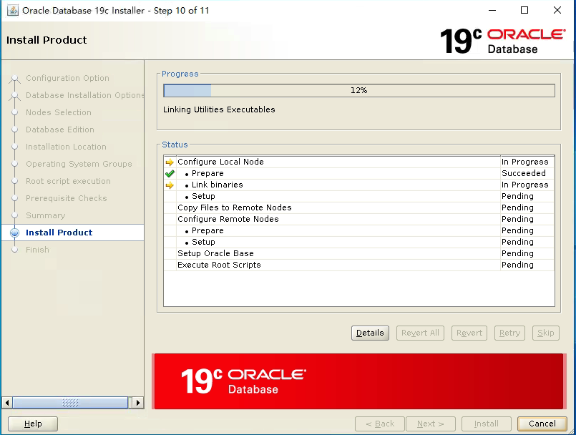

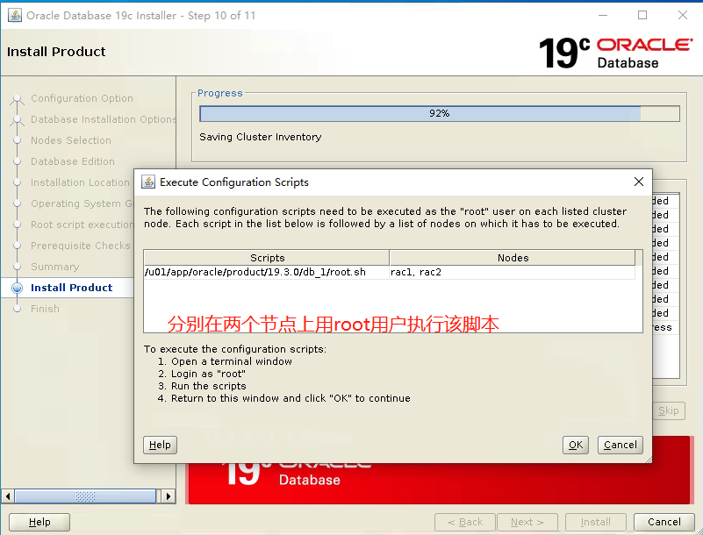

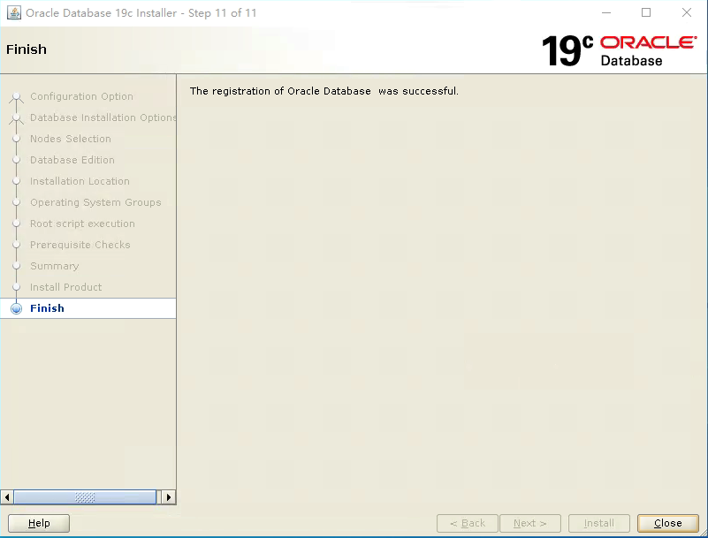

## 使用DBCA创建数据库

在oracle用户下执行dbca建库

[oracle@rac1 db_1]$ dbca

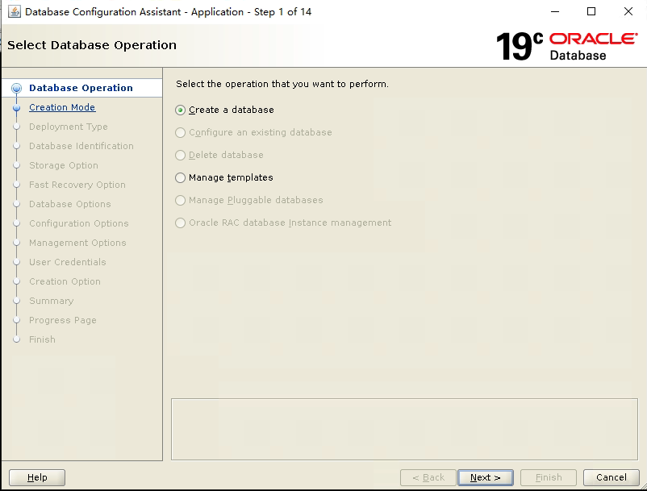

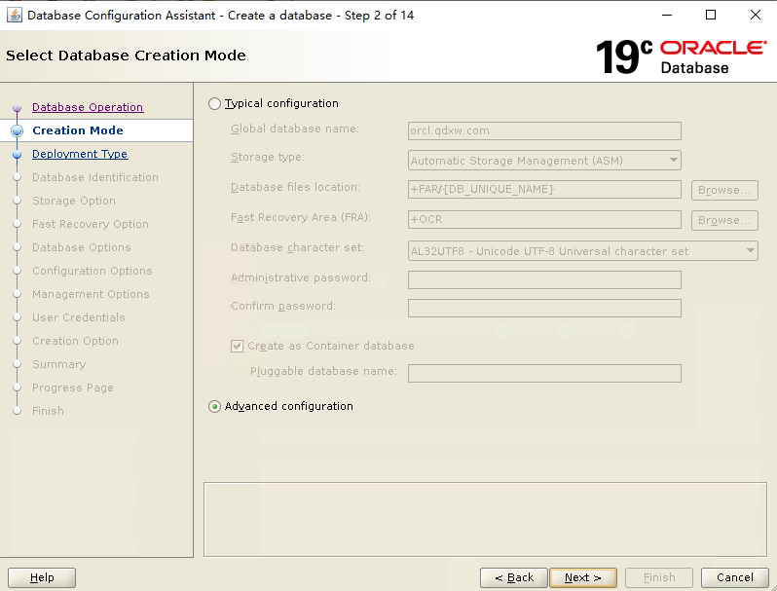

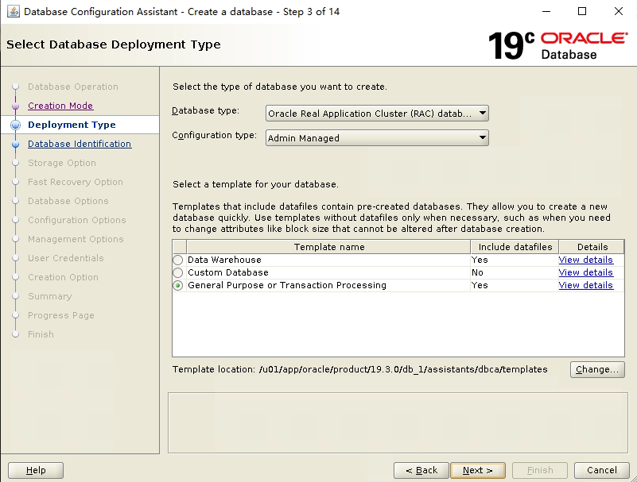

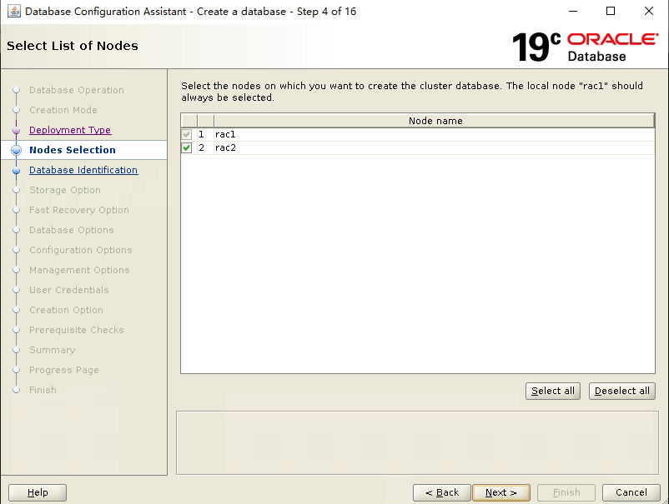

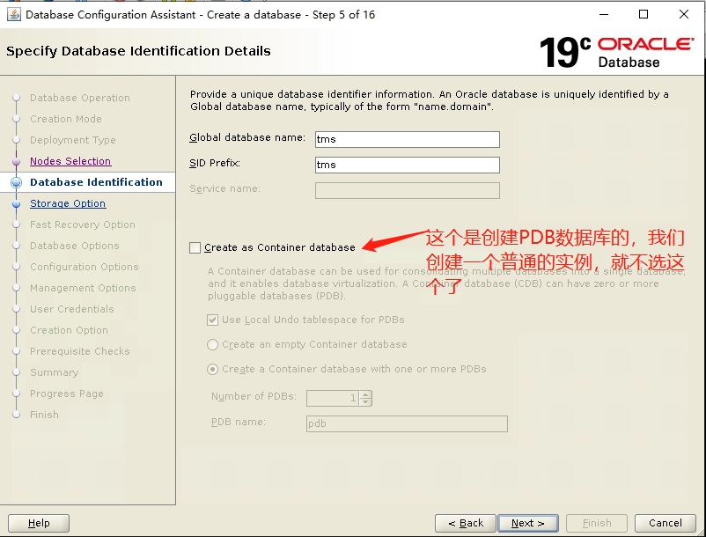

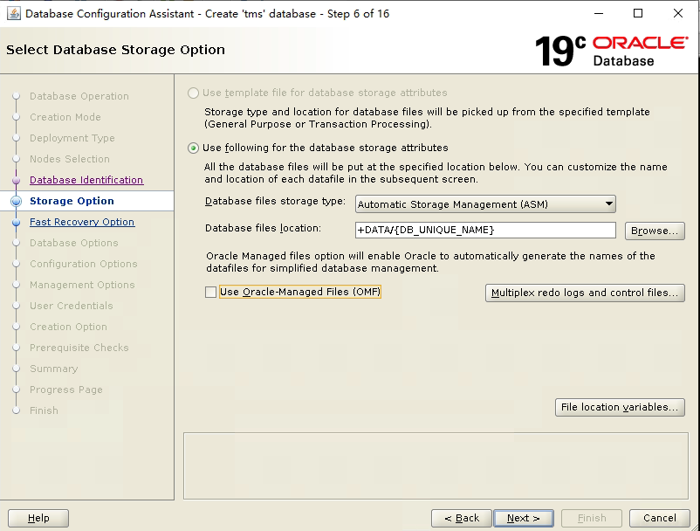

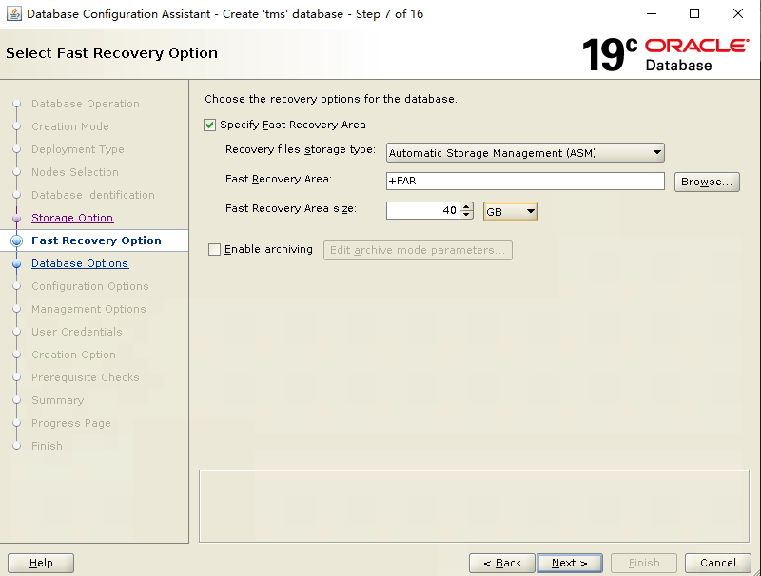

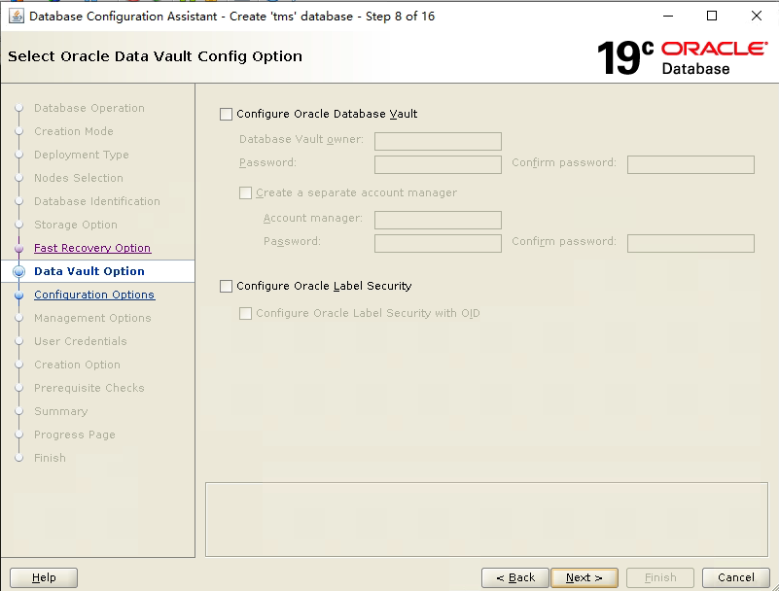

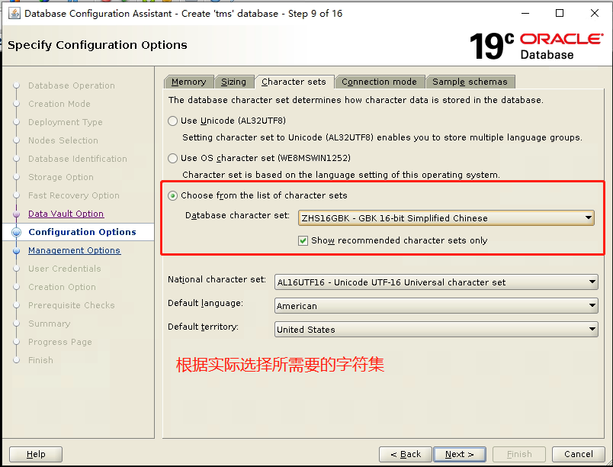

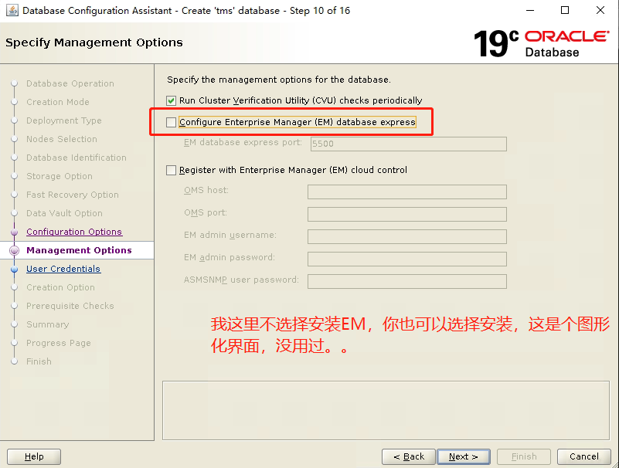

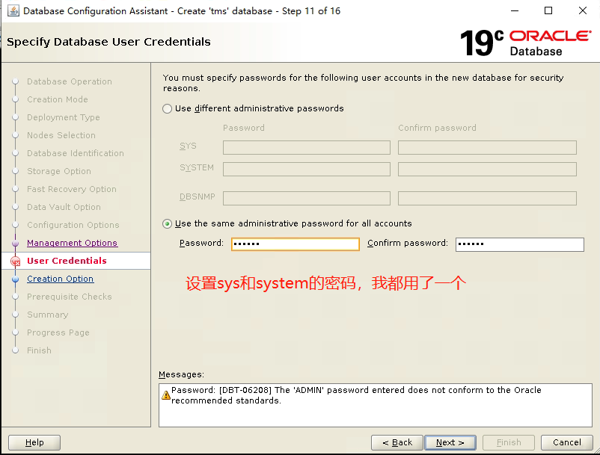

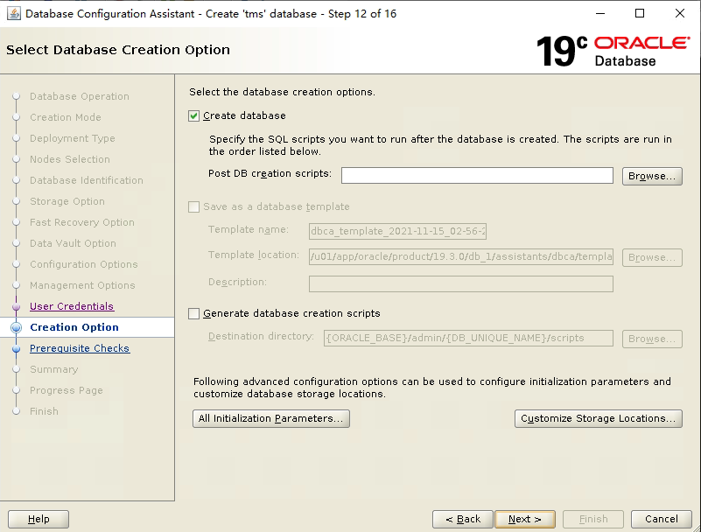

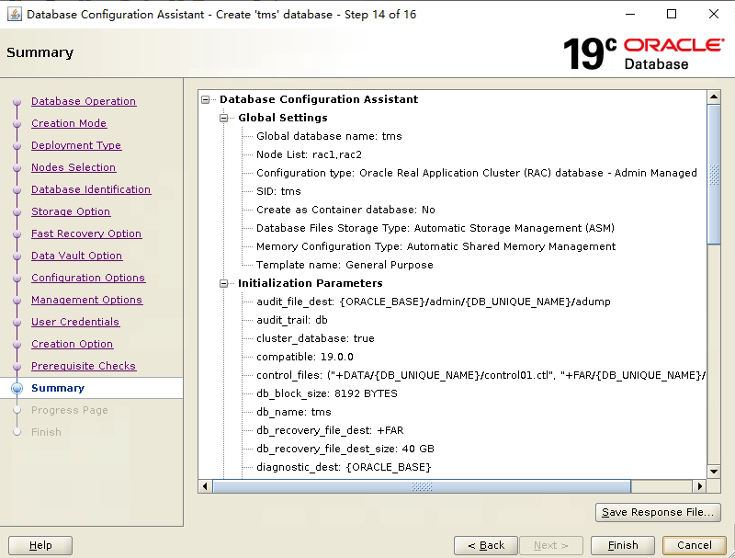

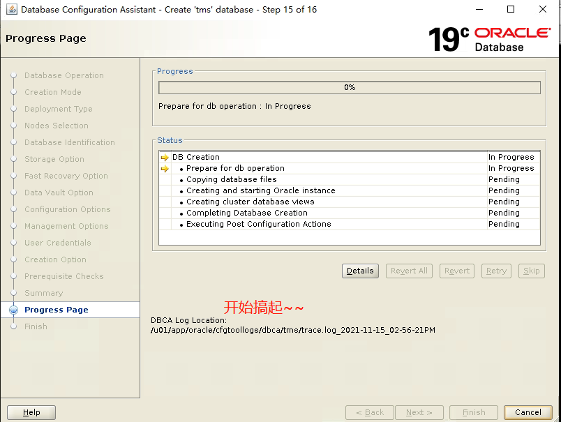

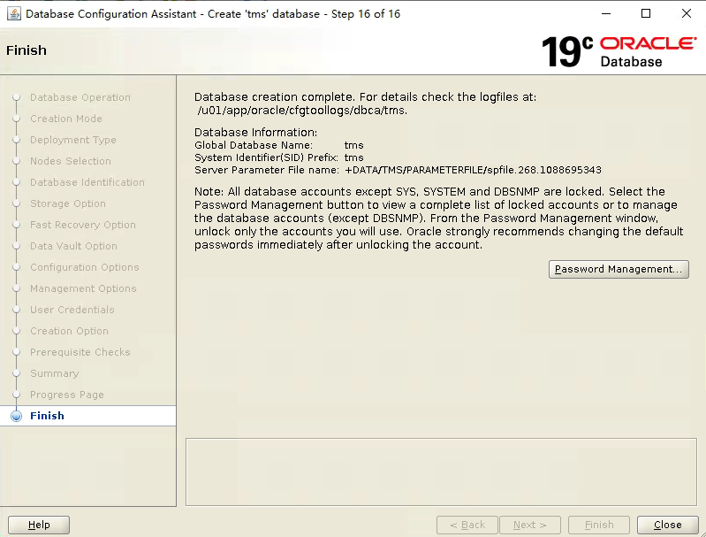

## 安装后的检查

### 检查集群实例运行状态

[grid@rac1 ~]$ srvctl status database -d tms

Instance tms1 is running on node rac1

Instance tms2 is running on node rac2

### 检查CRS状态

检查本地节点的CRS状态

[grid@rac1 ~]$ crsctl check crs

CRS-4638: Oracle High Availability Services is online

CRS-4537: Cluster Ready Services is online

CRS-4529: Cluster Synchronization Services is online

CRS-4533: Event Manager is online

检查集群的CRS状态

[grid@rac1 ~]$ crsctl check cluster

CRS-4537: Cluster Ready Services is online

CRS-4529: Cluster Synchronization Services is online

CRS-4533: Event Manager is online

### 查看集群中节点配置信息

[grid@rac1 ~]$ olsnodes -n -i -s -t

rac1 1 <none> Active Unpinned

rac2 2 <none> Active Unpinned

### 查看集群间的表决磁盘信息

[grid@rac1 ~]$ crsctl query css votedisk

## STATE File Universal Id File Name Disk group

-- ----- ----------------- --------- ---------

1. ONLINE b4e852395eda4f0fbf364751d5cef6ea (/dev/sdb) [OCR]

2. ONLINE 9680e4c5a15d4f42bf90e8e47288c0d3 (/dev/sdc) [OCR]

3. ONLINE 9058d0f8ddcc4fd1bf36177a8b96da97 (/dev/sdd) [OCR]

Located 3 voting disk(s)

### 查看集群scan vip信息

[grid@rac1 ~]$ srvctl config scan

SCAN name: grid-scan.qdxw.com, Network: 1

Subnet IPv4: 10.8.7.0/255.255.255.0/ens161, static

Subnet IPv6:

SCAN 1 IPv4 VIP: 10.8.7.117

SCAN VIP is enabled.

SCAN 2 IPv4 VIP: 10.8.7.118

SCAN VIP is enabled.

SCAN 3 IPv4 VIP: 10.8.7.116

SCAN VIP is enabled.

### 查看集群scan listener信息

[grid@rac1 ~]$ srvctl config scan_listener

SCAN Listeners for network 1:

Registration invited nodes:

Registration invited subnets:

Endpoints: TCP:1521

SCAN Listener LISTENER_SCAN1 exists

SCAN Listener is enabled.

SCAN Listener LISTENER_SCAN2 exists

SCAN Listener is enabled.

SCAN Listener LISTENER_SCAN3 exists

SCAN Listener is enabled.

### 手动漂移scan ip

[grid@rac1 ~]$ srvctl relocate scan_listener -i 1 -n rac1

### 手工漂移vip

[grid@rac1 ~]$ srvctl relocate vip -i rac1 -n rac2 -f -v

VIP was relocated successfully.

[grid@rac1 ~]$ srvctl relocate vip -i rac1 -n rac1 -f -v

VIP was relocated successfully

## 设置sqlprompt

[oracle@rac1 admin]$ pwd

/u01/app/oracle/product/19.3.0/db_1/sqlplus/admin

[oracle@rac1 admin]$ vi glogin.sql

添加set sqlprompt "_user'@'_connect_identifier> "

效果：

SYS@tms1>

## 添加新的本地监听

srvctl add listener -l listener_1522 -p 1522 -o $ORACLE_HOME -k 1

srvctl start listener -l listener_1522

## scan监听增加新的监听端口

srvctl modify scan_listener -p 1521,1522

srvctl modify scan_listener -u

srvctl stop scan_listener

srvctl start scan_listener

## ASM修改文件权限

pwget --dbuniquename hisdg

chown oracle pwdhis.ora 修改文件属组 属组修改完成之后不用修改权限

chmod 666 pwdemr.ora 修改文件权限

chmod 600 pwdemr.ora 修改文件权限

ls -l --permission 查看asm文件权限

## 搭建ADG

### 写在前面

如果使用 dg_broker方式来管理adg那么下面步骤中的第8步里的标红参数就不需要设置了，因为12c以后的版本这些参数都是有dg_broker来管理的。

### 1、主库设置force logging模式

主库节点1执行

SYS@TMS1> alter database force logging;

Database altered.

SYS@TMS1> select force_logging from v$database;

FORCE_LOGGING

---------------------------------------

YES

### 2、修改主库为归档模式

主库关闭所有节点

[oracle@rac1 ~]$ srvctl stop database -d TMS

主库任意节点启动至mount状态

SYS@TMS1> startup mount

修改log_archive_dest_1参数

SYS@TMS1> alter system set log_archive_dest_1='location=+far/tms/arch' scope=spfile sid='*';

修改log_archive_format参数（该参数可以修改也可以不修改）

SYS@TMS1> alter system set log_archive_format='arch_%d_%t_%s_%r.log' scope=spfile sid='*';

修改数据库为归档模式

SYS@TMS1> alter database archivelog;

关闭实例并重新启动数据库

SYS@TMS1> shutdown immediate

[oracle@rac1 ~]$ srvctl start database -d TMS

SYS@TMS1> alter database open;

Database altered.

SYS@TMS1> archive log list

Database log mode Archive Mode

Automatic archival Enabled

Archive destination +FAR/tms/arch

Oldest online log sequence 4

Next log sequence to archive 5

Current log sequence 5

### 3、主库添加standby redo log

rac每个redo thread都需要创建对应的standby redo log。创建原则和单实例一样，包括日志文件大小相等，日志组数量至少要多1组。

SYS@TMS1> col member for a50

SYS@TMS1> select a.thread#,a.group#,a.bytes/1024/1024,b.member from v$log a,v$logfile b where a.group#=b.group#;

THREAD# GROUP# A.BYTES/1024/1024 MEMBER

---------- ---------- ----------------- --------------------------------------------------

1 2 200 +DATA/TMS/redo02.log

1 1 200 +DATA/TMS/redo01.log

2 3 200 +DATA/TMS/redo03.log

2 4 200 +DATA/TMS/redo04.log

alter database add standby logfile thread 1 group 10 ('+data/tms/standby10.log') size 200m;

alter database add standby logfile thread 1 group 11 ('+data/tms/standby11.log') size 200m;

alter database add standby logfile thread 1 group 12 ('+data/tms/standby12.log') size 200m;

alter database add standby logfile thread 2 group 13 ('+data/tms/standby13.log') size 200m;

alter database add standby logfile thread 2 group 14 ('+data/tms/standby14.log') size 200m;

alter database add standby logfile thread 2 group 15 ('+data/tms/standby15.log') size 200m;

-------验证

SYS@TMS1> select group#,type,member from v$logfile order by 2;

GROUP# TYPE MEMBER

---------- ------- --------------------------------------------------

2 ONLINE +DATA/TMS/redo02.log

4 ONLINE +DATA/TMS/redo04.log

3 ONLINE +DATA/TMS/redo03.log

1 ONLINE +DATA/TMS/redo01.log

14 STANDBY +DATA/tms/standby14.log

13 STANDBY +DATA/tms/standby13.log

12 STANDBY +DATA/tms/standby12.log

11 STANDBY +DATA/tms/standby11.log

15 STANDBY +DATA/tms/standby15.log

10 STANDBY +DATA/TMS/standby10.log

### 4、配置主/备库为静态监听（两个节点都要配置）

修改主库监听文件listener.ora

[grid@rac1 ~]$ cd /u01/app/19.3.0/grid/network/admin/

[grid@rac1 admin]$ cp listener.ora listener.ora.bak ---备份一下，出问题可以恢复

[grid@rac1 admin]$ cat listener.ora

主库：

实例1

ENABLE_GLOBAL_DYNAMIC_ENDPOINT_LISTENER_SCAN1 = ON

SID_LIST_LISTENER =

(SID_LIST =

(SID_DESC =

(GLOBAL_DBNAME = orcl_DGMGRL)

(ORACLE_HOME = /u01/app/oracle/product/19.3.0/db_1)

(SID_NAME = tms1)

)

)

LISTENER =

(DESCRIPTION =

(ADDRESS = (PROTOCOL = IPC)(KEY = LISTENER))

)

ADR_BASE_LISTENER = /u01/app/grid

ENABLE_GLOBAL_DYNAMIC_ENDPOINT_LISTENER = ON

LISTENER_SCAN1 =

(DESCRIPTION =

(ADDRESS = (PROTOCOL = IPC)(KEY = LISTENER_SCAN1))

)

ADR_BASE_LISTENER_SCAN1 = /u01/app/grid

实例2

ENABLE_GLOBAL_DYNAMIC_ENDPOINT_LISTENER_SCAN1 = ON

SID_LIST_LISTENER =

(SID_LIST =

(SID_DESC =

(GLOBAL_DBNAME = orcl_DGMGRL)

(ORACLE_HOME = /u01/app/oracle/product/19.3.0/db_1)

(SID_NAME = tms2)

)

)

LISTENER =

(DESCRIPTION =

(ADDRESS = (PROTOCOL = IPC)(KEY = LISTENER))

)

ADR_BASE_LISTENER = /u01/app/grid

ENABLE_GLOBAL_DYNAMIC_ENDPOINT_LISTENER = ON

LISTENER_SCAN1 =

(DESCRIPTION =

(ADDRESS = (PROTOCOL = IPC)(KEY = LISTENER_SCAN1))

)

ADR_BASE_LISTENER_SCAN1 = /u01/app/grid

备库：

实例1

ENABLE_GLOBAL_DYNAMIC_ENDPOINT_LISTENER_SCAN1 = ON

SID_LIST_LISTENER =

(SID_LIST =

(SID_DESC =

(GLOBAL_DBNAME = tms_dg_DGMGRL)

(ORACLE_HOME = /u01/app/oracle/product/19.3.0/db_1)

(SID_NAME = tms1)

)

)

LISTENER =

(DESCRIPTION =

(ADDRESS = (PROTOCOL = IPC)(KEY = LISTENER))

)

ADR_BASE_LISTENER = /u01/app/grid

ENABLE_GLOBAL_DYNAMIC_ENDPOINT_LISTENER = ON

LISTENER_SCAN1 =

(DESCRIPTION =

(ADDRESS = (PROTOCOL = IPC)(KEY = LISTENER_SCAN1))

)

ADR_BASE_LISTENER_SCAN1 = /u01/app/grid

实例2

ENABLE_GLOBAL_DYNAMIC_ENDPOINT_LISTENER_SCAN1 = ON

SID_LIST_LISTENER =

(SID_LIST =

(SID_DESC =

(GLOBAL_DBNAME = tms_dg_DGMGRL)

(ORACLE_HOME = /u01/app/oracle/product/19.3.0/db_1)

(SID_NAME = orcl2)

)

)

LISTENER =

(DESCRIPTION =

(ADDRESS = (PROTOCOL = IPC)(KEY = LISTENER))

)

ADR_BASE_LISTENER = /u01/app/grid

ENABLE_GLOBAL_DYNAMIC_ENDPOINT_LISTENER = ON

LISTENER_SCAN1 =

(DESCRIPTION =

(ADDRESS = (PROTOCOL = IPC)(KEY = LISTENER_SCAN1))

)

ADR_BASE_LISTENER_SCAN1 = /u01/app/grid

### 5、配置主/备库tnsnames.ora（两个节点都要配置）

[oracle@rac1 ~]$ cd $ORACLE_HOME/network/admin

[oracle@rac1 admin]$ cp tnsnames.ora tnsnames.ora.bak

在主库两个节点的tnsnames.ora文件中添加如下内容：

tms=

(DESCRIPTION =

(ADDRESS = (PROTOCOL = TCP)(HOST = 192.168.200.2)(PORT = 1521))

(ADDRESS = (PROTOCOL = TCP)(HOST = 192.168.200.3)(PORT = 1521))

(CONNECT_DATA =

(SERVER = DEDICATED)

(SERVICE_NAME =tms)

)

)

tms_dg=

(DESCRIPTION =

(ADDRESS = (PROTOCOL = TCP)(HOST = 192.168.200.7)(PORT = 1521))

(CONNECT_DATA =

(SERVER = DEDICATED)

(SERVICE_NAME = tms_dg)

)

)

在备库两个节点的tnsnames.ora文件中添加如下内容：

tms=

(DESCRIPTION =

(ADDRESS = (PROTOCOL = TCP)(HOST = 192.168.200.2)(PORT = 1521))

(ADDRESS = (PROTOCOL = TCP)(HOST = 192.168.200.3)(PORT = 1521))

(CONNECT_DATA =

(SERVER = DEDICATED)

(SERVICE_NAME =tms)

)

)

tms_dg=

(DESCRIPTION =

(ADDRESS = (PROTOCOL = TCP)(HOST = 192.168.200.7)(PORT = 1521))

(CONNECT_DATA =

(SERVER = DEDICATED)

(SERVICE_NAME = tms_dg)

)

)

### 6、备库创建相应目录

两个节点创建adump路径

mkdir -p /u01/app/oracle/admin/TMS/adump

创建数据文件、日志文件、临时文件目录

[grid@rac3 ~]$ asmcmd

ASMCMD> cd +data

ASMCMD> mkdir –p TMS

创建快速恢复区

ASMCMD> cd +far

ASMCMD> mkdir -p TMS/arch

### 7、创建备库口令文件

主库操作

ASMCMD> pwcopy +data/tms/password/pwdtms.266.1088774287 /home/oracle/orapwTMS1

[oracle@rac2 ~]$ scp orapwTMS1 rac3.qdxw.com: /u01/app/oracle/product/19.3.0/db_1/dbs

### 8、修改主库参数并生成pfile文件

修改主库参数

alter system set log_archive_config='dg_config=(TMS,TMSDG)' scope=spfile sid='*';

alter system set log_archive_dest_1='location=+far/tms/arch valid_for=(all_logfiles,all_roles) scope=spfile sid=’*’;

alter system set log_archive_dest_2='service=TMS-DG lgwr async valid_for=(online_logfiles,primary_role) db_unique_name=TMSDG' scope=spfile sid='*';

alter system set standby_file_management='auto' scope=both sid='*';

alter system set fal_server='TMS-DG' scope=spfile sid='*';

alter system set db_file_name_convert='+DATA','+DATA' scope=spfile sid='*';

alter system set log_file_name_convert='+DATA','+DATA' scope=spfile sid='*';

注：主备库路径一致db_file_name_convert，log_file_name_convert两个参数可不用设置。

生成pfile文件

SYS@TMS1> create pfile='/home/oracle/ initTMS1.ora ' from spfile='+data/tms/parameterfile/spfile.268.1088775151';

主库pfile拷贝到备库中

scp /home/oracle/initTMS1.ora rac3.qdxw.com: /u01/app/oracle/product/19.3.0/db_1/dbs

备库编辑参数文件

*.audit_file_dest='/u01/app/oracle/admin/TMS/adump'

*.audit_trail='db'

*.cluster_database=true

*.compatible='19.0.0'

*.control_files='+DATA/TMS/control01.ctl','+FAR/TMS/control02.ctl'

*.db_block_size=8192

*.db_file_name_convert='+DATA','+DATA'

*.db_name='TMS'

*.db_unique_name='TMSDG'

*.db_recovery_file_dest='+FAR'

*.db_recovery_file_dest_size=40g

*.diagnostic_dest='/u01/app/oracle'

*.dispatchers='(PROTOCOL=TCP) (SERVICE=TMSXDB)'

*.fal_server='TMS'

family:dw_helper.instance_mode='read-only'

TMS2.instance_number=2

TMS1.instance_number=1

*.local_listener='-oraagent-dummy-'

*.log_archive_config='dg_config=(TMSDG,TMS)'

*.log_archive_dest_1='location=+far/tms/arch valid_for=(all_logfiles,all_roles) db_unique_name=TMSDG'

*.log_archive_dest_2='service=TMS lgwr async valid_for=(online_logfiles,primary_role) db_unique_name=TMS'

*.log_archive_dest_state_1='ENABLE'

*.log_archive_dest_state_2='ENABLE'

*.log_archive_format='arch_%d_%t_%s_%r.log'

*.log_file_name_convert='+DATA','+DATA'

*.nls_language='AMERICAN'

*.nls_territory='AMERICA'

*.open_cursors=300

*.pga_aggregate_target=1605m

*.processes=640

*.remote_login_passwordfile='exclusive'

*.sga_target=4812m

*.standby_file_management='auto'

TMS2.thread=2

TMS1.thread=1

TMS2.undo_tablespace='UNDOTBS2'

TMS1.undo_tablespace='UNDOTBS1'

### 9、备库启动至nomount状态

SQL> startup nomount

### 10、开始duplicate

[oracle@rac1 ~]$ rman target sys/oracle@TMS auxiliary sys/oracle@TMS-DG

Recovery Manager: Release 19.0.0.0.0 - Production on Tue Nov 16 16:30:43 2021

Version 19.3.0.0.0

Copyright (c) 1982, 2019, Oracle and/or its affiliates. All rights reserved.

connected to target database: TMS (DBID=1350343692)

connected to auxiliary database: TMS (not mounted)

RMAN> duplicate target database for standby from active database dorecover nofilenamecheck;

注：如果在RMAN恢复时不指定 nofilenamecheck 参数，则在数据文件相同文件名恢复时会出现RMAN-05501错误，当主库，备库的数据库文件目录是一样的时候，必须使用 nofilenamecheck参数告诉rman主库和被创建的备份库拥有一样的文件目录和文件名。

### 11、备库创建spfile

SQL> create spfile='+data/tms/parameter' from pfile='/u01/app/oracle/product/19.3.0/db_1/dbs/initTMS1.ora';

### 12、备库复制密码口令文件到ASM

[oracle@rac3 dbs]$ asmcmd pwcopy /u01/app/oracle/product/19.3.0/db_1/dbs/orapwTMS1 +DATA/TMS/password/orapwtms

### 13、备库添加rac资源

[oracle@rac3 dbs]$ srvctl add database -db TMSDG -dbname TMS -oraclehome $ORACLE_HOME -dbtype RAC -role PHYSICAL_STANDBY

[oracle@rac3 dbs]$ srvctl add instance -db TMSDG -instance TMS1 -node rac3

[oracle@rac3 dbs]$ srvctl add instance -db TMSDG -instance TMS2 -node rac4

[oracle@rac3 dbs]$ srvctl modify database -db TMSDG -spfile '+data/tms/parameterfile/spfileTMS.ora' -pwfile '+data/tms/password/orapwtms' -diskgroup DATA

### 14、启动MRP进程

SQL> ALTER DATABASE RECOVER MANAGED STANDBY DATABASE USING CURRENT LOGFILE DISCONNECT FROM SESSION;

断开日志同步

SQL>  ALTER DATABASE RECOVER MANAGED STANDBY DATABASE CANCEL;

### 15、主备配置dg_borker

#### 主备配置参数

主库操作

SYS@TMS1> alter system set dg_broker_start=false scope=both sid='*';

SYS@TMS1> alter system set dg_broker_config_file1='+data/n4/dr1n4.dat' scope=both sid='*';

SYS@TMS1> alter system set dg_broker_config_file2='+data/n4/dr2n4.dat' scope=both sid='*';

SYS@TMS1> alter system set dg_broker_start=true scope=spfile sid='*';

备库操作

SYS@TMS1> alter system set dg_broker_start=false scope=both sid='*';

SYS@TMS1> alter system set dg_broker_config_file1='+data/n4dg/dr1n4dg.dat' scope=both sid='*';

SYS@TMS1> alter system set dg_broker_config_file2='+data/n4dg/dr2n4dg.dat' scope=both sid='*';

SYS@TMS1> alter system set dg_broker_start=true scope=both sid='*';

#### 主库节点创建DGMGRL

[oracle@rac3 admin]$ dgmgrl sys/oracle@N4

DGMGRL for Linux: Release 19.0.0.0.0 - Production on Wed Nov 17 20:43:35 2021

Version 19.3.0.0.0

Copyright (c) 1982, 2019, Oracle and/or its affiliates. All rights reserved.

Welcome to DGMGRL, type "help" for information.

Connected to "N4"

Connected as SYSDBA.

DGMGRL> show configuration;

ORA-16532: Oracle Data Guard broker configuration does not exist

Configuration details cannot be determined by DGMGRL

DGMGRL> create configuration adg as primary database is N4 connect identifier is N4;

Configuration "adg" created with primary database "n4"

DGMGRL> add database N4DG as connect identifier is N4-DG maintained as physical;

Database "n4dg" added

DGMGRL> edit database 'N4DG' set state='apply-on';

Error: ORA-16555: member is not active

Failed.

DGMGRL> enable configuration;

Enabled.

DGMGRL> show configuration;

Configuration - adg

Protection Mode: MaxPerformance

Members:

n4 - Primary database

n4dg - Physical standby database

Fast-Start Failover: Disabled

Configuration Status:

SUCCESS (status updated 29 seconds ago)

DGMGRL> show database N4DG

Database - n4dg

Role: PHYSICAL STANDBY

Intended State: APPLY-ON

Transport Lag: 0 seconds (computed 0 seconds ago)

Apply Lag: 0 seconds (computed 1 second ago)

Average Apply Rate: 183.00 KByte/s

Real Time Query: ON -----on：代表已经启用实时同步查询 off：代表没有实时同步查询

Instance(s):

N41 (apply instance)

N42

Database Status:

SUCCESS

DGMGRL> show database N4

Database - n4

Role: PRIMARY

Intended State: TRANSPORT-ON

Instance(s):

N41

N42

Database Status:

SUCCESS

#### 主备启用flashback database

SYS@N41> show parameter db_recovery

NAME TYPE VALUE

------------------------------------ ----------- ------------------------------

db_recovery_file_dest string +FAR

db_recovery_file_dest_size big integer 40G

SYS@N41> select flashback_on from v$database;

FLASHBACK_ON

------------------

NO

得到的值有两种情况：YES 或者 NO，分别表示开启和关闭。

如果需要打开或关闭，需要在mount状态下使用下面的命令：

alter database flashback on;

### 16、主备进行切换

#### 不使用db_broker进行切换

##### switchover

1、原主库进行操作

1）查看库的角色，和可以切换到的角色

SYS@TMS1> select database_role,switchover_status from v$database;

DATABASE_ROLE SWITCHOVER_STATUS

---------------- --------------------

PRIMARY TO STANDBY

2）对主库进行切换，rac集群关闭第二个节点。（如果SWITCHOVER_STATUS的值为TO

STANDBY或者为SESSIONS ACTIVE都可以切换至备库）

SYS@TMS1> alter database commit to switchover to physical standby with session shutdown;

Database altered.

3）开启原先的主库至于OPEN状态，查看切换后的状态

SYS@TMS1> select open_mode,database_role,switchover_status from v$database;

OPEN_MODE DATABASE_ROLE SWITCHOVER_STATUS

-------------------- ---------------- --------------------

READ ONLY PHYSICAL STANDBY TO PRIMARY

4）开启实时查询同步

SYS@TMS1> ALTER DATABASE RECOVER MANAGED STANDBY DATABASE USING CURRENT LOGFILE DISCONNECT FROM SESSION;

Database altered.

2、原备库操作

1）查看备库是否可以切换至主库（SWITCHOVER_STATUS的值为TO PRIMARY或者SESSIONS ACTIVE都可以切换至主库）

SYS@TMS1> select switchover_status from v$database;

SWITCHOVER_STATUS

--------------------

TO PRIMARY

2）将备库切换到主库并打开

SYS@TMS1> ALTER DATABASE COMMIT TO SWITCHOVER TO PRIMARY WITH SESSION SHUTDOWN;

Database altered.

3）查看切换完成后的状态

SYS@TMS1> select open_mode,database_role,switchover_status from v$database;

OPEN_MODE DATABASE_ROLE SWITCHOVER_STATUS

-------------------- ---------------- --------------------

READ WRITE PRIMARY TO STANDBY

##### faillover

假设物理主库宕机，无法启动，紧急启用备库。直接在备库上操作，将备库转换为主库角色。备库上执行下面四条命令即可

SQL > alter database recover managed standby database finish;

SQL > alter database commit to switchover to primary;

SQL > shutdown immediate;

SQL > startup;

具体操作

直接备库failover切换

SQL> alter database recover managed standby database finish;

Database altered.

再直接备库转换为主库

SQL> alter database commit to switchover to primary;

关闭备库

SQL> shutdown immediate

ORA-01109: database not open

Database dismounted.

ORACLE instance shut down.

开启备库

SQL> startup

查看转换角色

SQL> select open_mode,database_role,switchover_status from v$database;

OPEN_MODE DATABASE_ROLE SWITCHOVER_STATUS

---------- ---------------- -------------------- ------------------------------------

READ WRITE PRIMARY NOT ALLOWED

现在备库成为了主库角色，failover切换完成；

#### 使用db_broker进行切换

##### switchover

主库切换一般2-3分钟可用，备库在5-7分钟恢复open。

任意节点执行下面操作均可：

dgmgrl sys/oracle@N4 或 dgmgrl sys/oracle@N4-DG

DGMGRL> show configuration;

Configuration - adg

Protection Mode: MaxPerformance

Members:

n4dg - Primary database

n4 - Physical standby database

Fast-Start Failover: Disabled

Configuration Status:

SUCCESS (status updated 56 seconds ago)

DGMGRL> switchover to N4

Performing switchover NOW, please wait...

New primary database "n4" is opening...

Oracle Clusterware is restarting database "n4dg" ...

Connected to "N4DG"

Connected to an idle instance.

Connected to an idle instance.

Connected to an idle instance.

Connected to an idle instance.

Connected to an idle instance.

Connected to an idle instance.

Connected to an idle instance.

Connected to "N4DG"

Connected to "N4DG"

Switchover succeeded, new primary is "n4"

DGMGRL> show configuration;

Configuration - adg

Protection Mode: MaxPerformance

Members:

n4 - Primary database

n4dg - Physical standby database

Fast-Start Failover: Disabled

Configuration Status:

SUCCESS (status updated 108 seconds ago)

##### fastfaillover(验证失败，待优化)

1、dgmgrl 查看主库状态

[oracle@rac3 ~]$ dgmgrl sys/oracle@N4

DGMGRL for Linux: Release 19.0.0.0.0 - Production on Thu Nov 18 10:00:18 2021

Version 19.3.0.0.0

Copyright (c) 1982, 2019, Oracle and/or its affiliates. All rights reserved.

Welcome to DGMGRL, type "help" for information.

Connected to "N4"

Connected as SYSDBA.

DGMGRL> show configuration;

Configuration - adg

Protection Mode: MaxPerformance

Members:

n4 - Primary database

n4dg - Physical standby database

Fast-Start Failover: Disabled

Configuration Status:

SUCCESS (status updated 105 seconds ago)

#快速故障转移Disabled代表没有启用

DGMGRL> show fast_start failover

Fast-Start Failover: Disabled

Protection Mode: MaxPerformance

Lag Limit: 30 seconds

Threshold: 30 seconds

Active Target: (none)

Potential Targets: (none)

Observer: (none)

Shutdown Primary: TRUE

Auto-reinstate: TRUE

Observer Reconnect: (none)

Observer Override: FALSE

Configurable Failover Conditions

Health Conditions:

Corrupted Controlfile YES

Corrupted Dictionary YES

Inaccessible Logfile NO

Stuck Archiver NO

Datafile Write Errors YES

Oracle Error Conditions:

(none)

2、启动快速启动故障转移

DGMGRL> enable fast_start failover;

Enabled in Potential Data Loss Mode.

3、启动快速启动故障转移observer观察程序

DGMGRL> start observer;

[W000 2021-11-18T10:08:40.500+08:00] FSFO target standby is n4dg

Observer 'rac3' started

[W000 2021-11-18T10:08:41.495+08:00] Observer trace level is set to USER

[W000 2021-11-18T10:08:41.495+08:00] Try to connect to the primary.

[W000 2021-11-18T10:08:41.495+08:00] Try to connect to the primary n4.

[W000 2021-11-18T10:08:41.596+08:00] The standby n4dg is ready to be a FSFO target

[W000 2021-11-18T10:08:42.596+08:00] Connection to the primary restored!

[W000 2021-11-18T10:08:44.597+08:00] Disconnecting from database n4.

#这个窗口貌似只能在前台运行，关闭了这个窗口，这个程序就没了。然后DGMGRL里面会有个报错Error: ORA-16820: fast-start failover observer is no longer observing this database

至此dgmgrl 配置的fast_start failover已经配置好，下面模拟故障切换过程。

可以通过shutdown abort模拟数据库意外垮掉的情况，

注：主库shutdown immediate是不会启动fast start failover功能的。

### 17、维护

查看主备课的日志应用状态

select sequence#,applied from v$archived_log order by sequence#;

查备库进程

select process,client_process,sequence#,status,BLOCK#,BLOCKS from v$managed_standby;

查看备库延迟

select name,value,unit,time_computed from v$dataguard_stats where name in ('transport lag','apply lag');